**AMERICAN INTERNATIONAL UNIVERSITY BANGLADESH (AIUB)**

**FACULTY OF SCIENCE & TECHNOLOGY**



Course Title

**INTRODUCTION TO DATABASE (CSC2108)**

**Semester:   
Section: [ ]**

**TITLE**

**Name of your Project system**

**Supervised By**

Name of the Faculty

**Submitted By: Group no: xx**

|  |  |
| --- | --- |
| **Name** | **ID** |
|  |  |
|  |  |
|  |  |
|  |  |

**TABLE OF CONTENTS**

|  |  |  |
| --- | --- | --- |
| **TOPICS** | | **Page no.** |
| **Title Page** | | **1** |
| **Table of Content** | | **2** |
| **1.** | **Introduction** | **3** |
| **2.** | **Case Study** | **4** |
| **3.** | **ER Diagram** | **5** |
| **4.** | **Normalization** | **6-14** |
| **5.** | **Finalization** | **15** |
| **6.** | **Table Creation** | **16-22** |
| **7.** | **Data Insertion** | **23-29** |
| **8.** | **Query Test** | **30-34** |
| **9.** | **DB connection** | **35** |
|  |  |  |
|  |  |  |

# **Introduction**

Demonstrate / explain the topic of your project. The tools that you are going to use in it. Your vision or goal after the accomplishment of the project. Your contribution in the tech sector through this project. Which sort of people will be benefitted from this kind of project and whom are your targeted users.

# **Case Study / Scenario**

One patient can do many appointment. Patient is identified by serial number(p_sn). The system also store name(p_name) , address(p_address), dob(p_dob), age(p_age), phone number(p_phone). Address(p_address) is composed of city(p_city), district(p_district). Age(p_age) is dependent on dob(p_dob). Phone number(p_phone) is a multiple variable.  Appointment is identified appointment id(a_id). The system also store doctor name (d_name),date(a_date) and time(a_time). One patient has one insurance. Insurance is identified by insurance id(i_id) . The system also store provider name(i_store_provider), address(i_address) and phone number(i_phone). Phone number(i_phone) has multiple variables. On the other hand address is composed of city(i_city), district(i_district). Many patients has many medical history. Medical history is identified by history id(mh_history_id). The systems also store patient id(p_id) , medical condition(mh_mc),date(mh_date), treatment history(mh_treatment_history). Treatment history is composed of doctor treatment cost(t_cost) , doctor name(d_name). One Patient can hire many doctor . Doctor is identified by doctor id(d_id). The system also store phone number(d_phone), hiredate(d_hiredate) , bonus(d_bonus) , address(d_address). Address(d_address) is composed of city(d_city), district(d_district).Phone number(d_phone) has multiple variables. One patient can do many treatment. Treatment is identified by treatment id(t_id). The system also store treatment cost(t_cost) and treatment type(t_type) . Many treatment are done by one doctor.  Many patients can do many bill . Bill is identified by transaction id(bill_id) . The system also store  bill date(bill_date), bill time(bill_time), transaction method(bill_transaction) , bill name(bill_name). Bill transaction is composed of first transaction(f_transaction) and last transaction(l_transaction)

# **ER Diagram**

## Provide the jpg/png file of your ER diagram after the drafts being checked by your course teacher

## you can use any of the diagraming tools like Dia Diagram, visio, lucidchart, draw.io etc

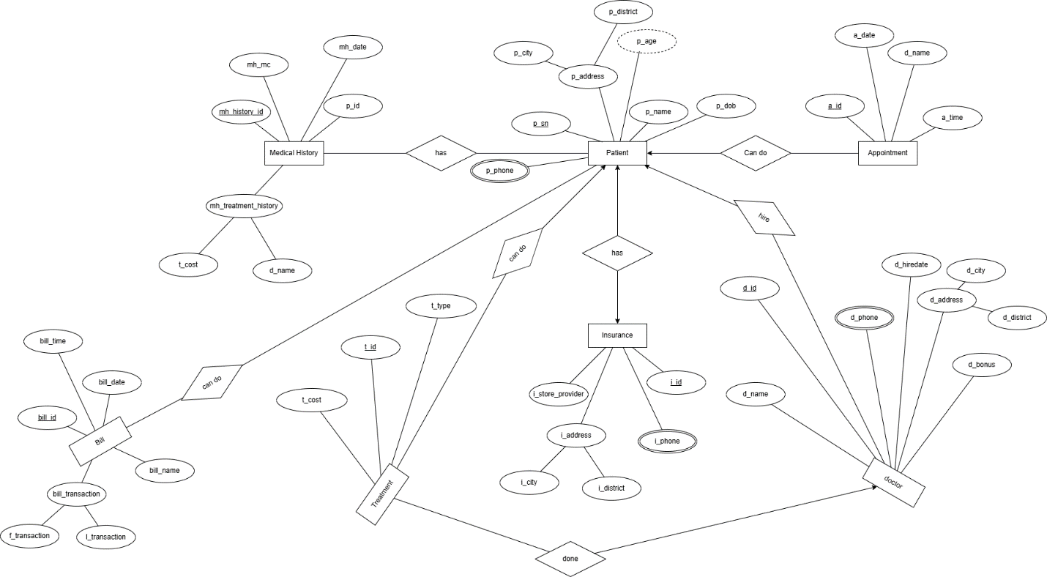

# **Normalization**

## Show the process of normalization up to 3NF for all the relations in the ER diagram

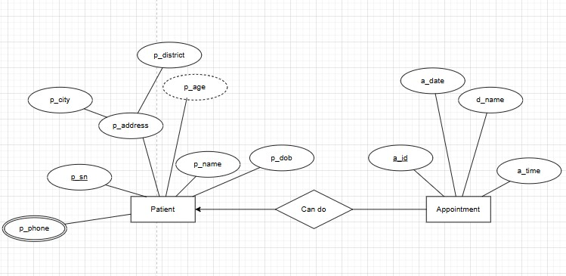

**Relation:** One to Many

**UNF:** p_phone,p_sn, p_city,p_district,p_name,p_dob,p_age,a_id, a_date, d_name,a_time

**1NF:**  Multivalue attribute: p_phone

p_sn, p_city,p_district,p_name,p_dob,p_age,a_id, a_date, d_name,a_time

**2NF:**  1) p_sn.p_phone

          2)p_sn,p_district,p_city,p_dob,p_age,p_name

          3)a_id, a_date,d_name,a_time,p_sn

**3NF:** 1) p_sn, p_phone

         2) p_sn, p_city,p_district

         3) p_sn, p_dob,p_age,p_name

         4)a_id, a_date,d_name,a_time,p_sn

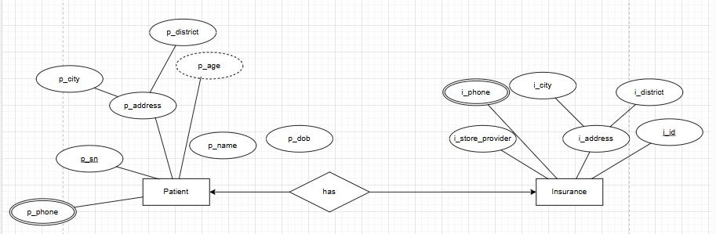

**Relation:** One to One

**UNF:** p_phone,i_phone,p_sn, p_city,p_district,p_name,p_dob,p_age,i_id, i_store_provider,i_city,i_district,i_phone

**1NF:**  Multivalue attribute: p_phone,i_phone

p_sn, p_city,p_district,p_name,p_dob,p_age,i_id, i_store_provider,i_city,i_district,i_phone

**2NF:**  1) p_sn.p_phone

          2)p_sn,p_district,p_city,p_dob,p_age,p_name

          3)i_id,  i_phone

          4)i_id, i_store_provider,i_city,i_district

**3NF:** 1) p_sn, p_phone

         2) p_sn, p_city,p_district

         3) p_sn, p_dob,p_age,p_name

         4)i_id,i_city,i_district

         5)i_id, i_store_provider

         6)i_id,i_phone

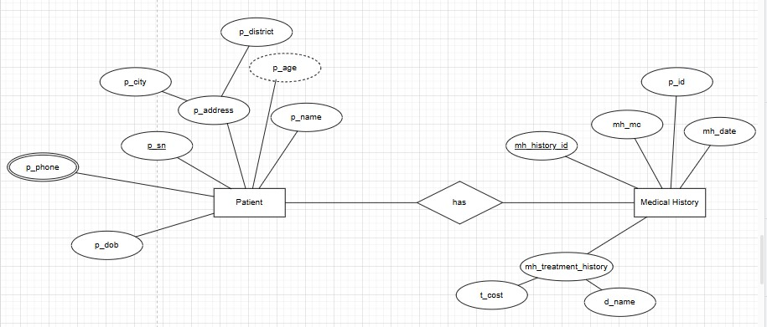

***Patient ->Medical History***

**Relation:** many to many

**UNF:** p_phone,p_sn, p_city,p_district,p_name,p_dob,p_age,mh_history_id, mh_mc, mh_date, p_id, t_cost,d_name

**1NF:**  Multivalue attribute: p_phone

p_sn, p_city,p_district,p_name,p_dob,p_age,mh_history_id, mh_mc, mh_date, p_id, t_cost,d_name

**2NF:**  1) p_sn.p_phone

          2)p_sn,p_district,p_city,p_dob,p_age,p_name

          3)mh_history_id,  mh_mc,mh_date,p_id,t_cost,d_name,p_sn

**3NF:** 1) p_sn, p_phone

         2) p_sn, p_city,p_district

         3) p_sn, p_dob,p_age,p_name

         4)mh_history_id,t_cost,d_name

         5)mh_history_id, mh_mc,mh_date,p_id,p_sn

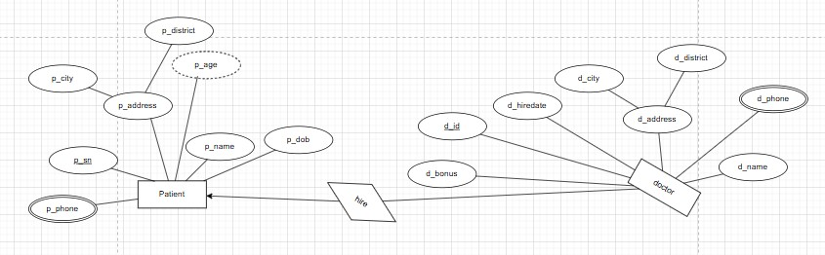

**Relation:** One to many

**UNF:**  p_phone,d_phone,p_sn, p_city,p_district,p_name,p_dob,p_age, d_id, d_name,d_bonus, d_hiredate,d_city,d_district

**1NF:**  Multivalue attribute: p_phone,d_phone

p_sn, p_city,p_district,p_name,p_dob,p_age, d_id, d_name,d_bonus, d_hiredate,d_city,d_district

**2NF:**  1) p_sn.p_phone

          2)p_sn,p_district,p_city,p_dob,p_age,p_name

          3)d_id, d_phone

          3)d_id, d_name,d_hiredate,d_city,d_d_district,d_bonus,p_sn

**3NF:** 1) p_sn, p_phone

         2) p_sn, p_city,p_district

         3) p_sn, p_dob,p_age,p_name

         4)d_id, d_phone

         5)d_id, d_city,d_district

         6)d_id, d_name,d_bonus,d_hiredate,p_sn

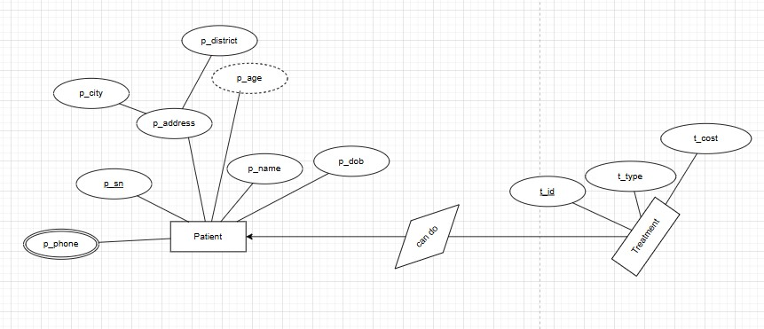

**Relation:** One to many

**UNF:** p_phone,p_sn, p_city,p_district,p_name,p_dob,p_age, t_id, t_cost,t_type

**1NF:**  Multivalue attribute: p_phone

p_sn, p_city,p_district,p_name,p_dob,p_age, t_id, t_cost,t_type

**2NF:**  1) p_sn.p_phone

          2)p_sn,p_district,p_city,p_dob,p_age,p_name

          3)t_id, t_cost, t_type,p_sn

**3NF:** 1) p_sn, p_phone

         2) p_sn, p_city,p_district

         3) p_sn, p_dob,p_age,p_name

         4)t_id, t_cost,t_type,p_sn

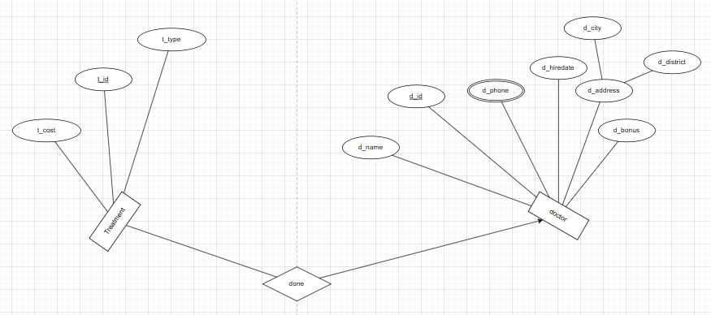

**Relation:** many to one

**UNF:** d_phone, t_id, t_cost,t_type, d_id, d_name,d_bonus, d_hiredate,d_city,d_district

**1NF:**  Multivalue attribute: d_phone

 t_id, t_cost,t_type, d_id, d_name,d_bonus, d_hiredate,d_city,d_district

**2NF:**  1) t_id,t_cost,t_type,d_id

          2)d_id, d_phone

          3)d_id, d_name,d_bonus,d_hiredate,d_city,d_district

**3NF:** 1)t_id,t_cost,t_type,d_id

         4)d_id, d_phone

         5)d_id, d_city,d_district

         6)d_id, d_name,d_bonus,d_hiredate

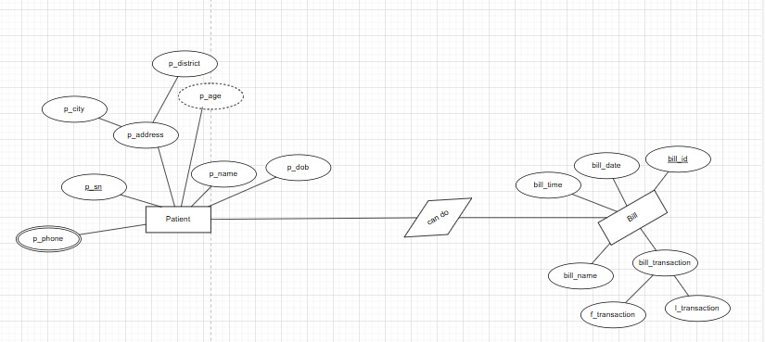

**Relation:** many to many

**UNF:** p_phone, p_sn, p_city,p_district,p_name,p_dob,p_age, bill_id, bill_time,bill_date,f_transaction,l_transaction,bill_name

**1NF:**  Multivalue attribute: p_phone

p_sn, p_city,p_district,p_name,p_dob,p_age, bill_id, bill_time,bill_date,f_transaction,l_transaction,bill_name

**2NF:**  1) p_sn.p_phone

          2)p_sn,p_district,p_city,p_dob,p_age,p_name

          3)bill_id, bill_time,bill_date,f_transaction,l_transaction,bill_name,p_sn

**3NF:** 1) p_sn, p_phone

         2) p_sn, p_city,p_district

         3) bill_id,f_transaction,l_transaction

         4)bill_id,bill_time,bill_date,bill_name, p_sn

# **Finalization**

## Eliminate the duplicate tables if found any in normalization after 3NF. Show the final tables of the system with their name.

**TOTAL RELATIONS**

1. p_sn, p_phone
2. p_sn, p_city,p_district
3. p_sn, p_dob,p_age,p_name
4. a_id, a_date,d_name,a_time,p_sn
5. ~~p_sn, p_phone~~
6. ~~p_sn, p_city,p_district~~
7. ~~p_sn, p_dob,p_age,p_name~~
8. i_id,i_city,i_district
9. i_id, i_store_provider
10. i_id,i_phone
11. ~~p_sn, p_phone~~
12. ~~p_sn, p_city,p_district~~
13. ~~p_sn, p_dob,p_age,p_name~~
14. mh_history_id,t_cost,d_name
15. mh_history_id, mh_mc,mh_date,p_id,p_sn
16. ~~p_sn, p_phone~~
17. ~~p_sn, p_city,p_district~~
18. ~~p_sn, p_dob,p_age,p_name~~
19. d_id, d_phone
20. d_id, d_city,d_district
21. d_id, d_name,d_bonus,d_hiredate,p_sn
22. ~~p_sn, p_phone~~
23. ~~p_sn, p_city,p_district~~
24. ~~p_sn, p_dob,p_age,p_name~~
25. ~~t_id, t_cost,t_type~~
26. t_id, t_cost,t_type,p_sn
27. t_id,t_cost,t_type,d_id
28. ~~d_id, d_phone~~
29. ~~d_id, d_city,d_district~~
30. ~~d_id, d_name,d_bonus,d_hiredate~~
31. ~~p_sn, p_phone~~
32. ~~p_sn, p_city,p_district~~
33. bill_id,f_transaction,l_transaction
34. bill_id,bill_time,bill_date,bill_name, p_sn

**TOTAL RELATIONS**

1. p_sn, p_phone
2. p_sn, p_city,p_district
3. p_sn, p_dob,p_age,p_name
4. a_id, a_date,d_name,a_time,p_sn
5. i_id,i_city,i_district
6. i_id, i_store_provider
7. i_id,i_phone
8. mh_history_id,t_cost,d_name
9. mh_history_id, mh_mc,mh_date,p_id,p_sn
10. d_id, d_phone
11. d_id, d_city,d_district
12. d_id, d_name,d_bonus,d_hiredate,p_sn
13. t_id, t_cost,t_type,p_sn
14. t_id,t_cost,t_type,d_id
15. bill_id,f_transaction,l_transaction
16. bill_id,bill_time,bill_date,bill_name, p_sn

# **Table Creation (DDL Operations)**

|  |  |  |
| --- | --- | --- |
| StudentID1: Name: | StudentID3: Name: | |
| StudentID2: Name: | StudentID4: Name: | |
| **CO4**: Creating DML, DDL using Oracle and connection with ODBC/JDBC for existing JAVA application | | |
| **PO-e-2:** Use modern engineering and IT tools for prediction and modeling of complex computer science and engineering problem | | Marks |

## Provide the screenshots of your commands for created tables in oracle.   
## Provide the description which shows the structure of the table.

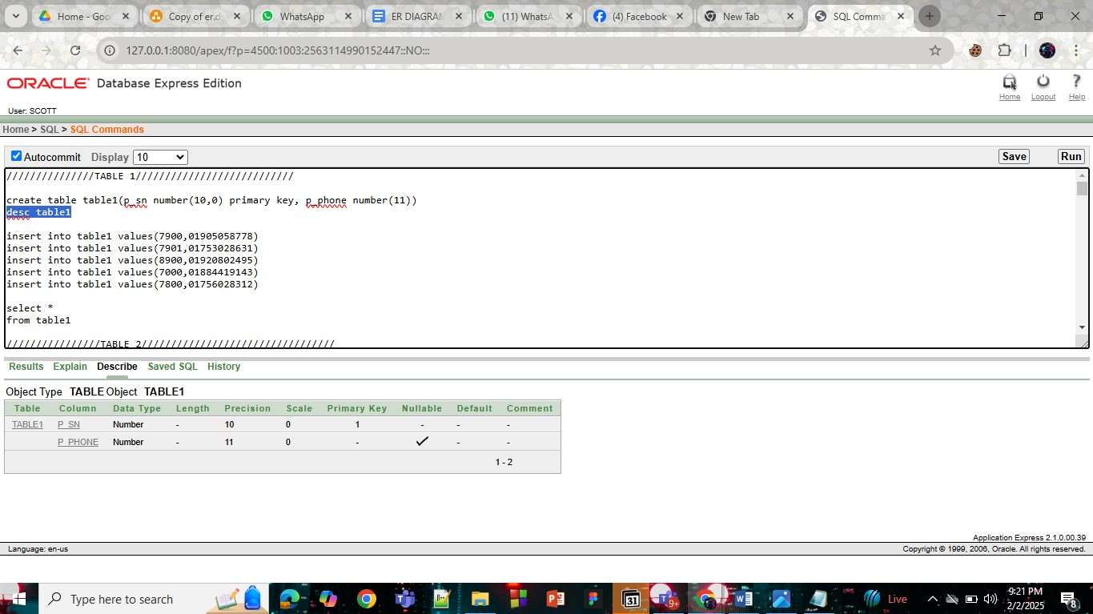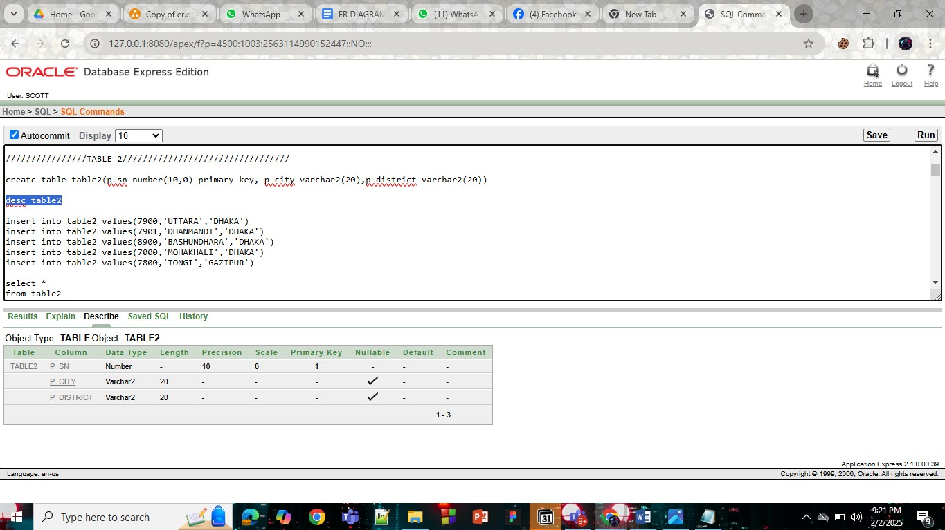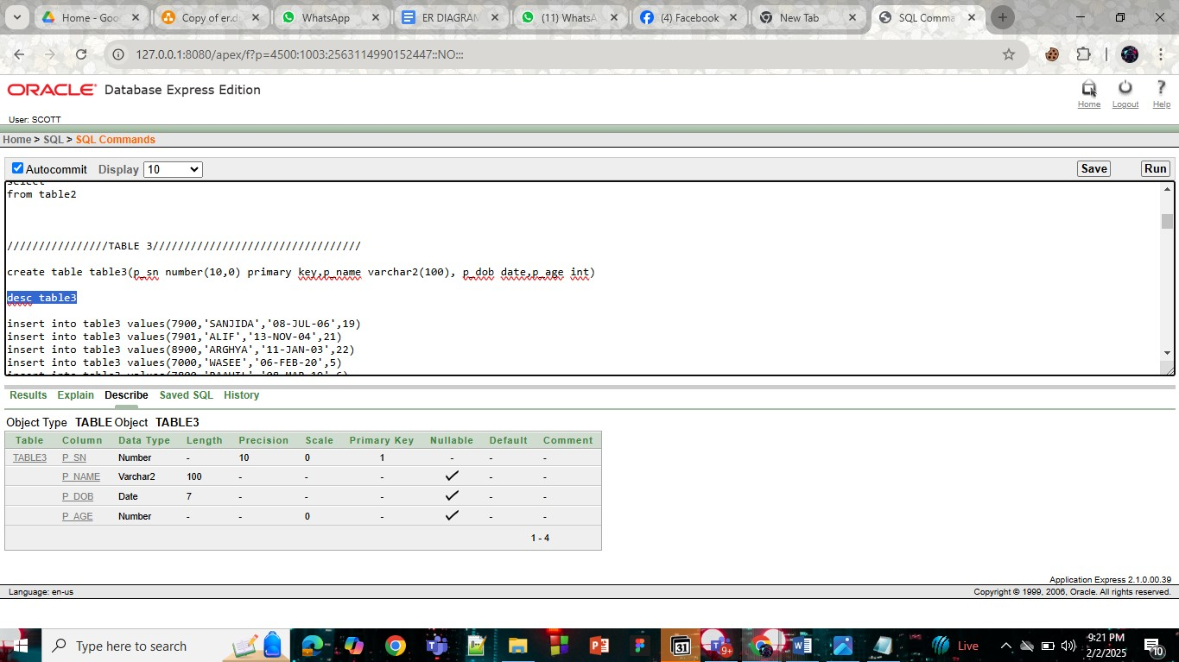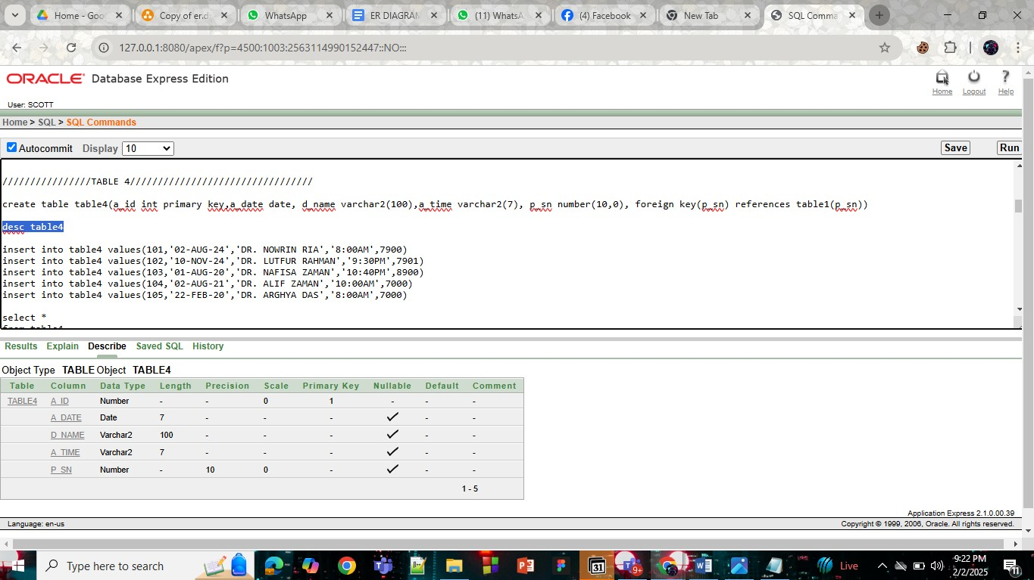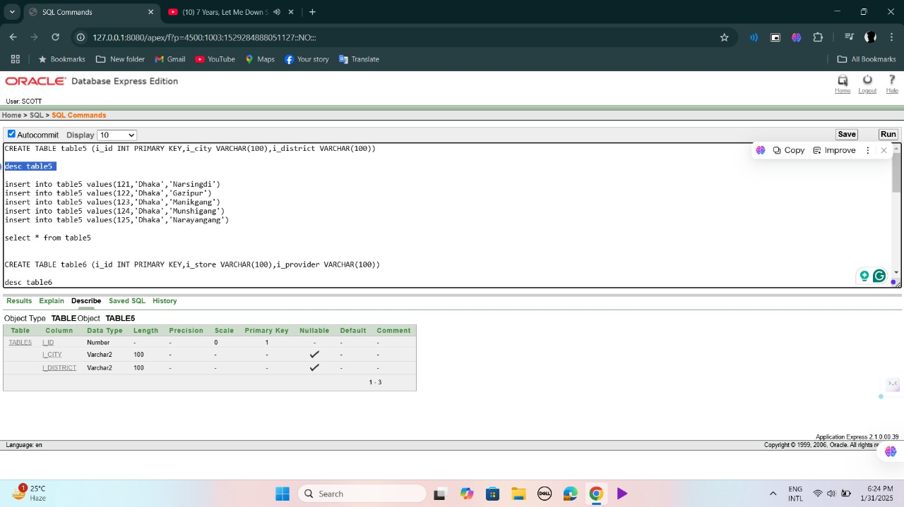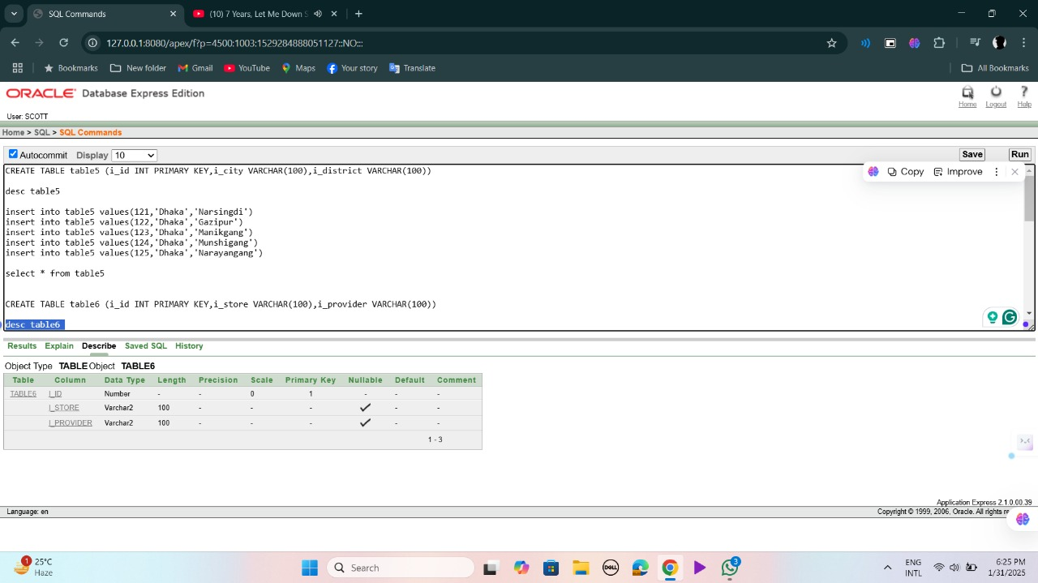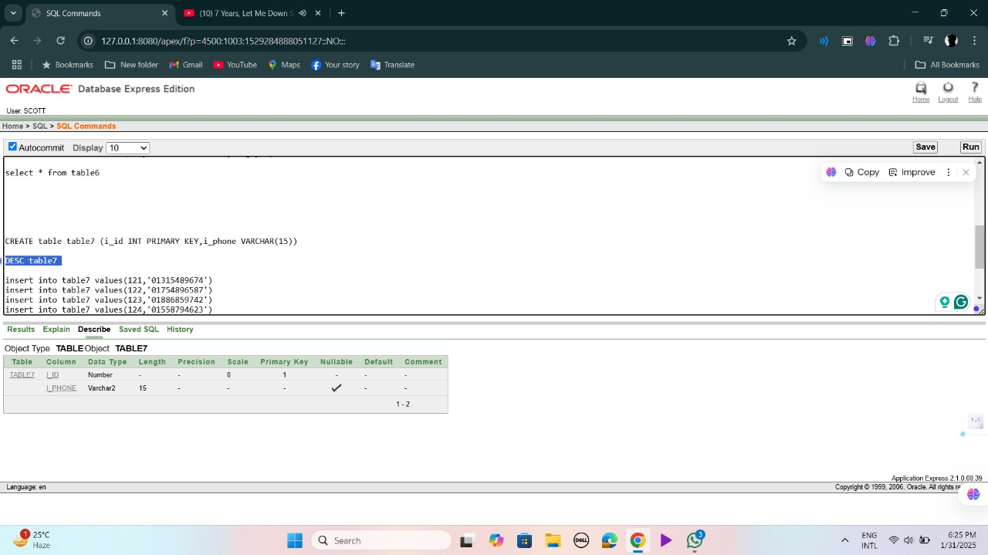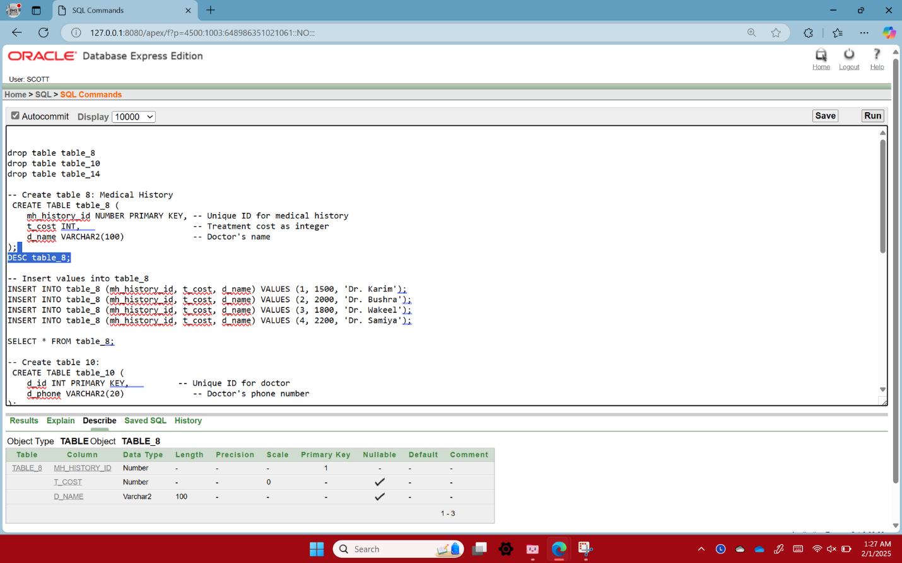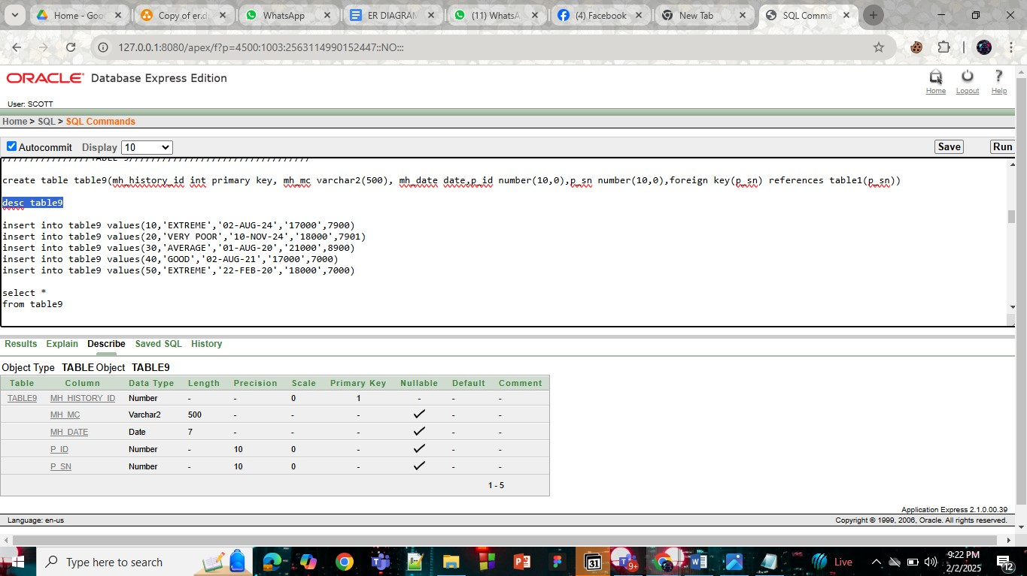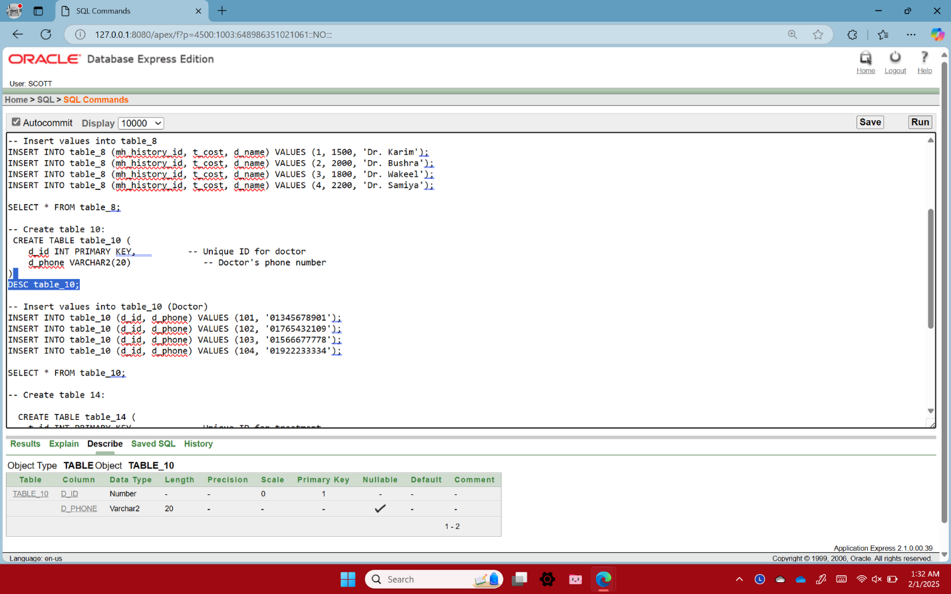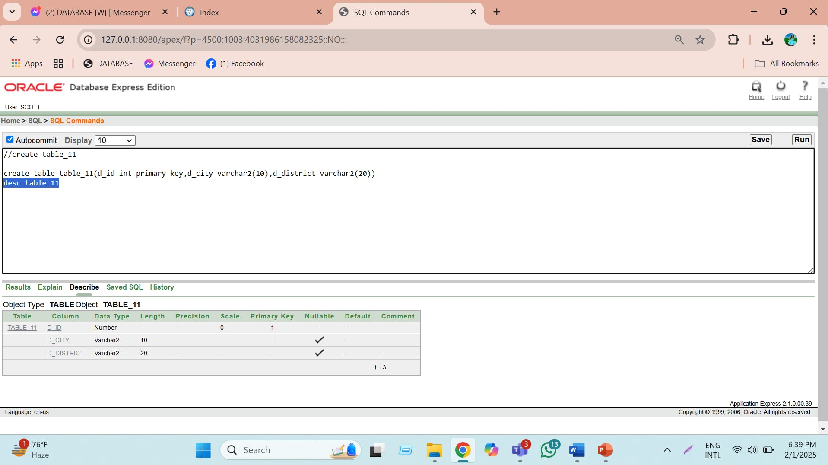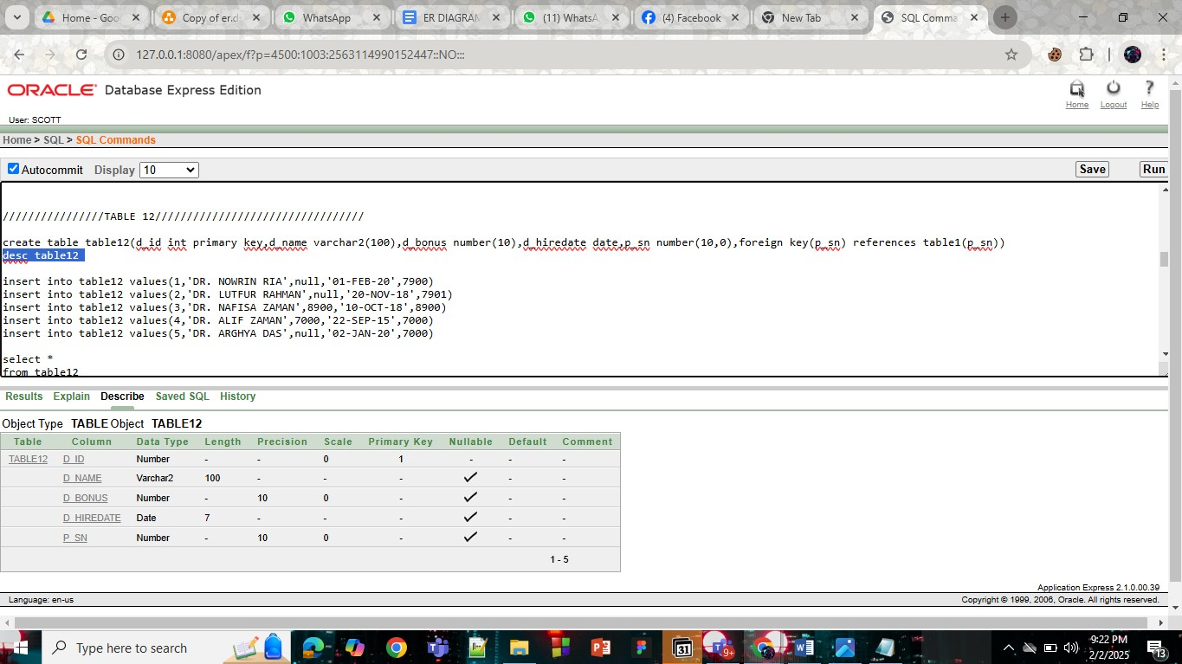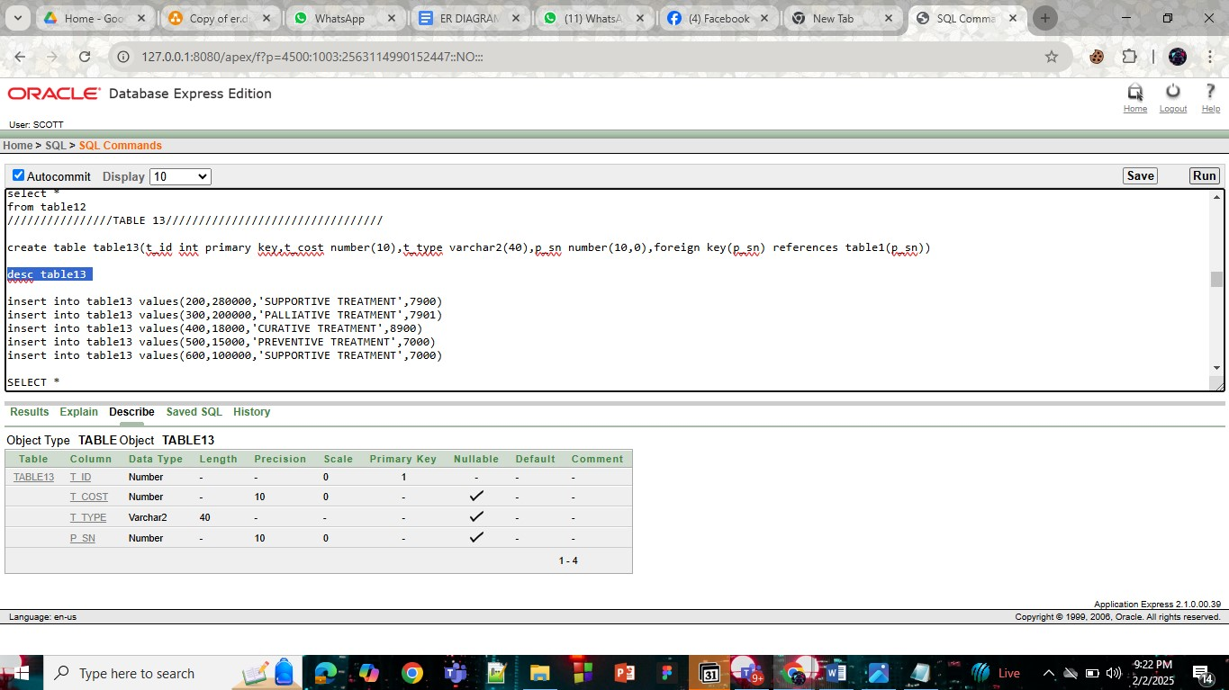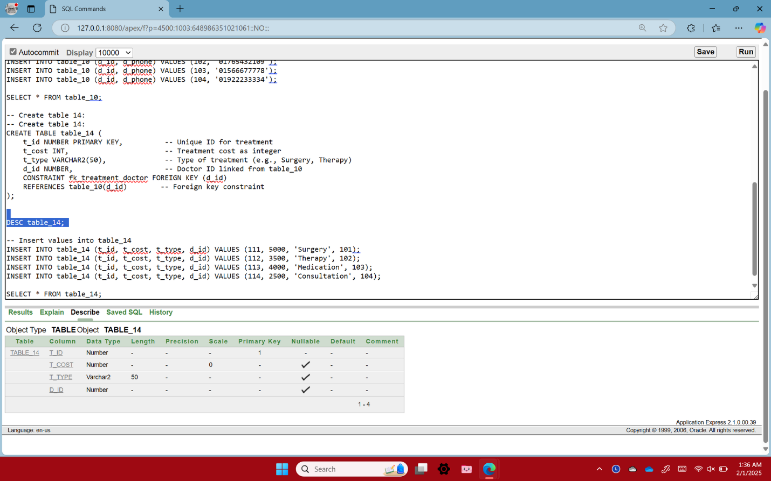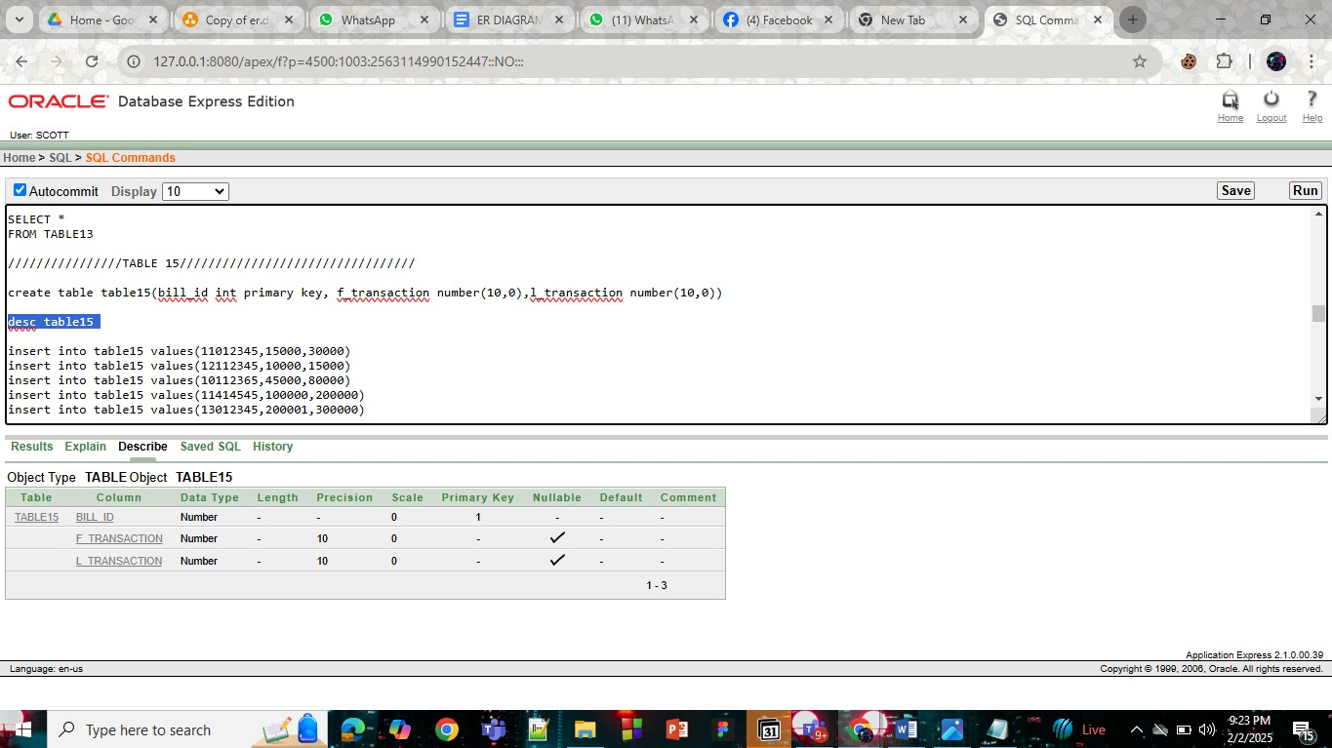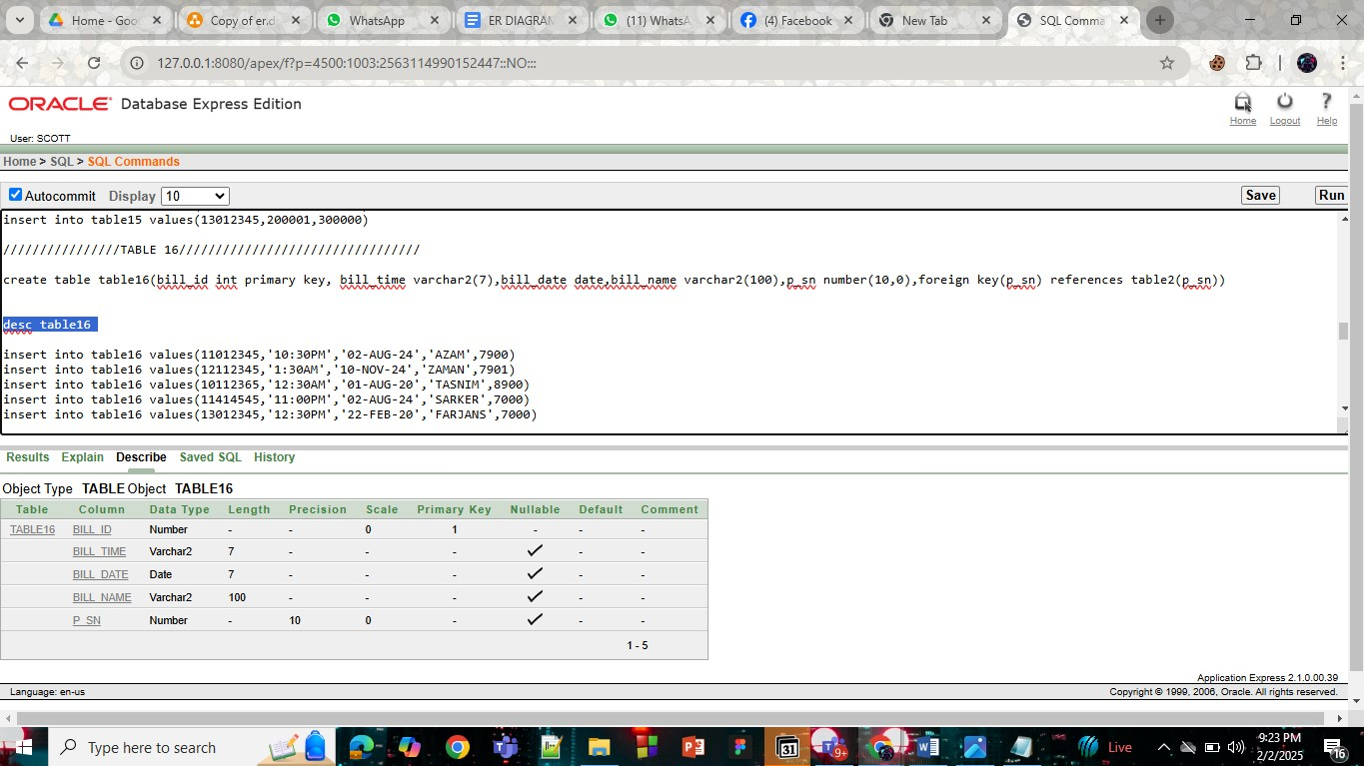

# **Inserted Values in the tables**

## Give the screenshot of all the created tables in Oracle. All the tables should be attached one by one.

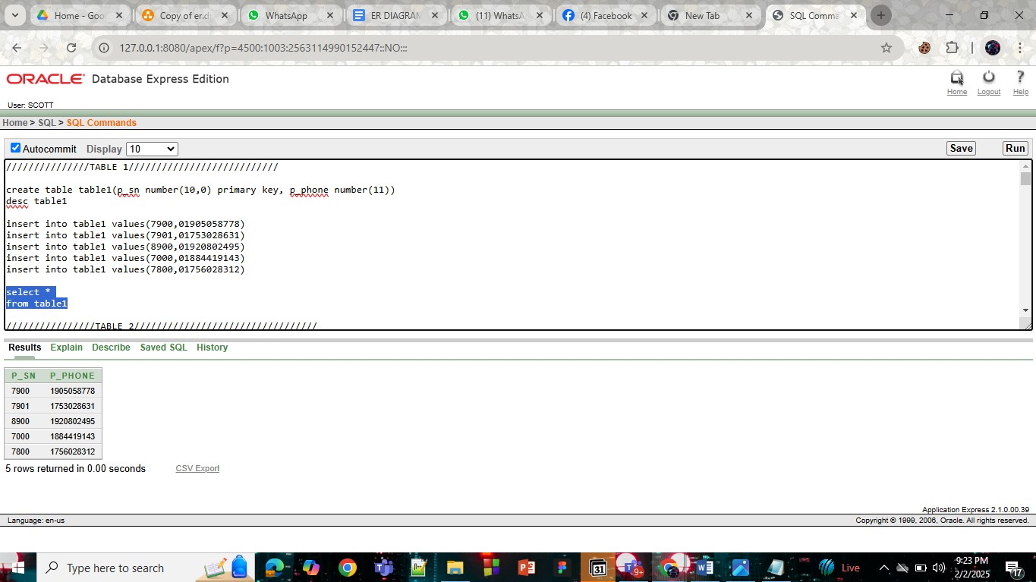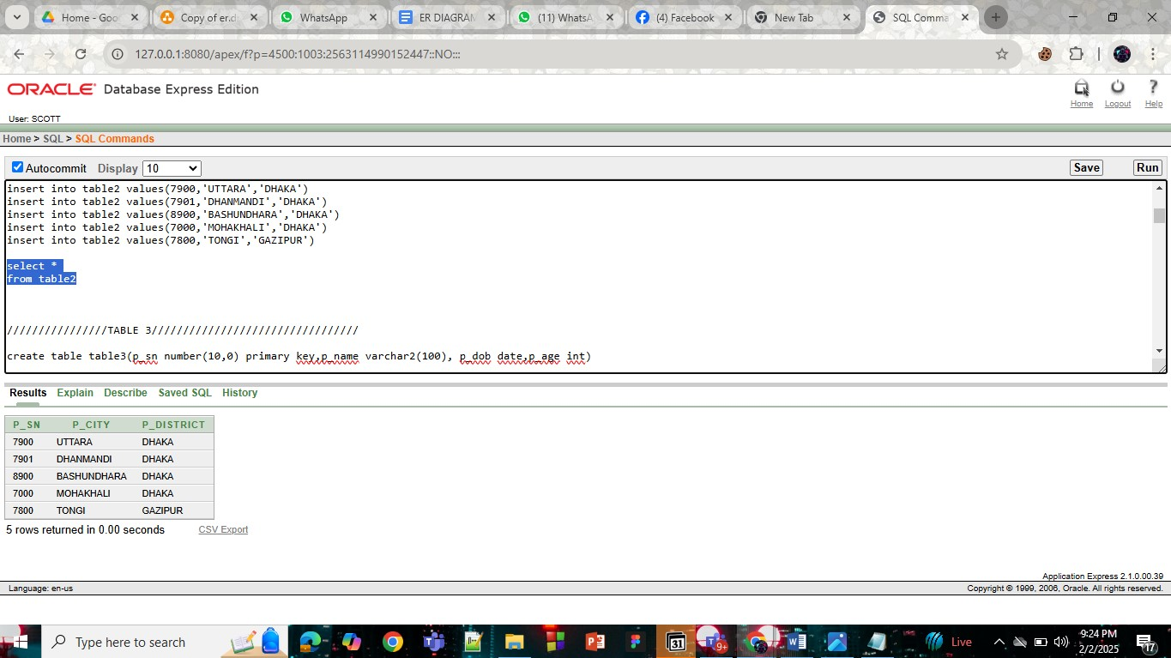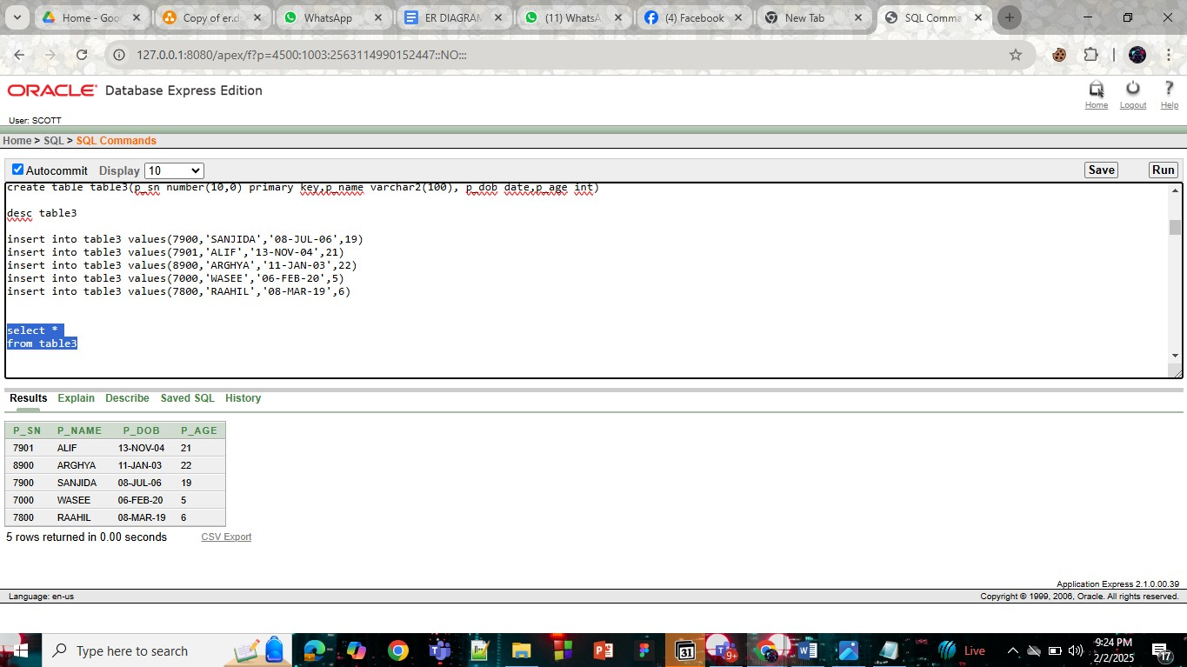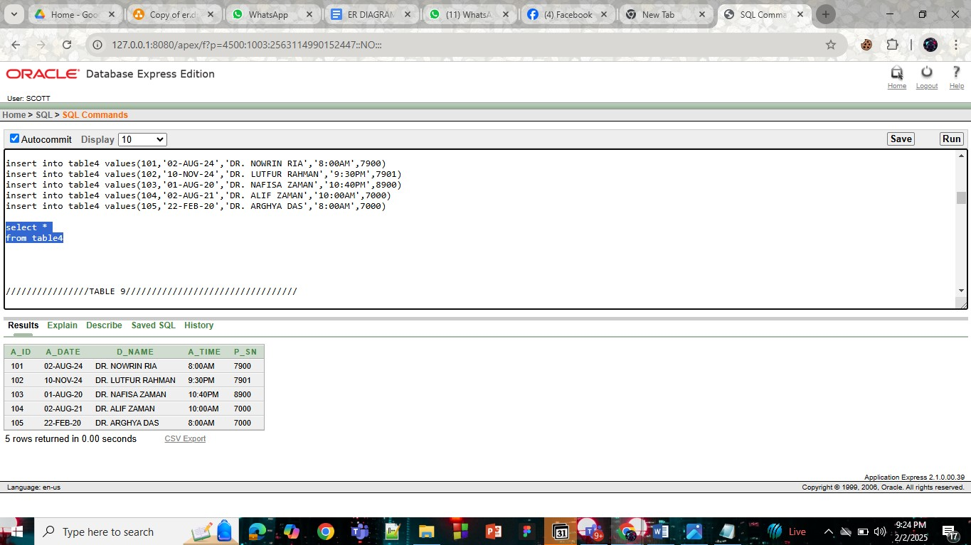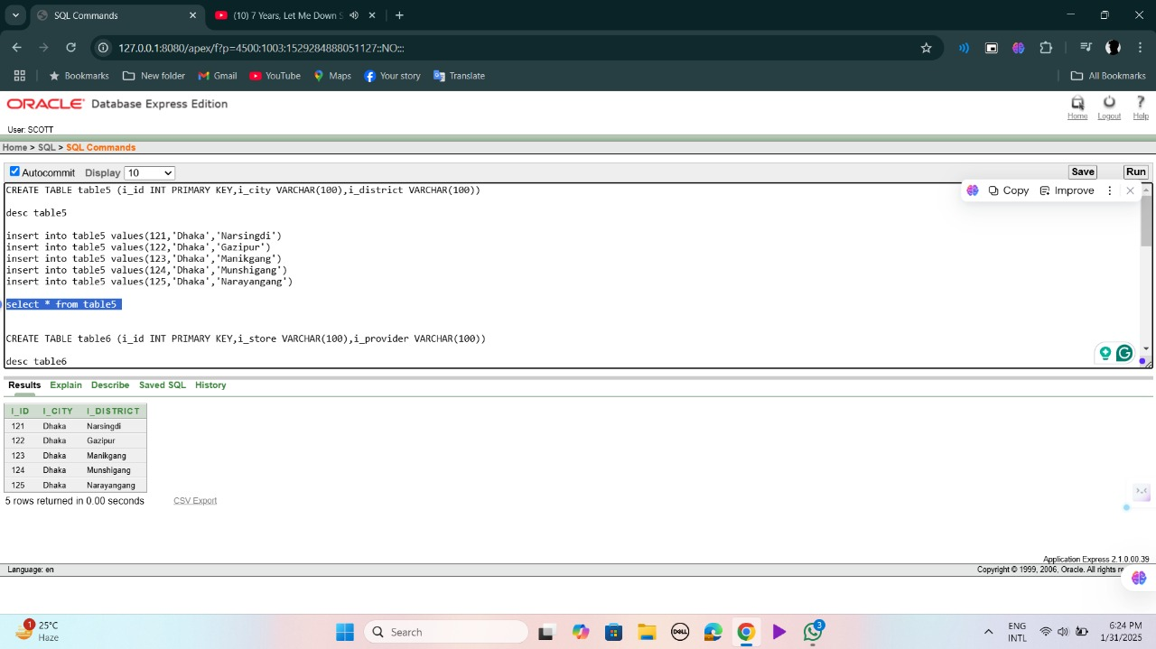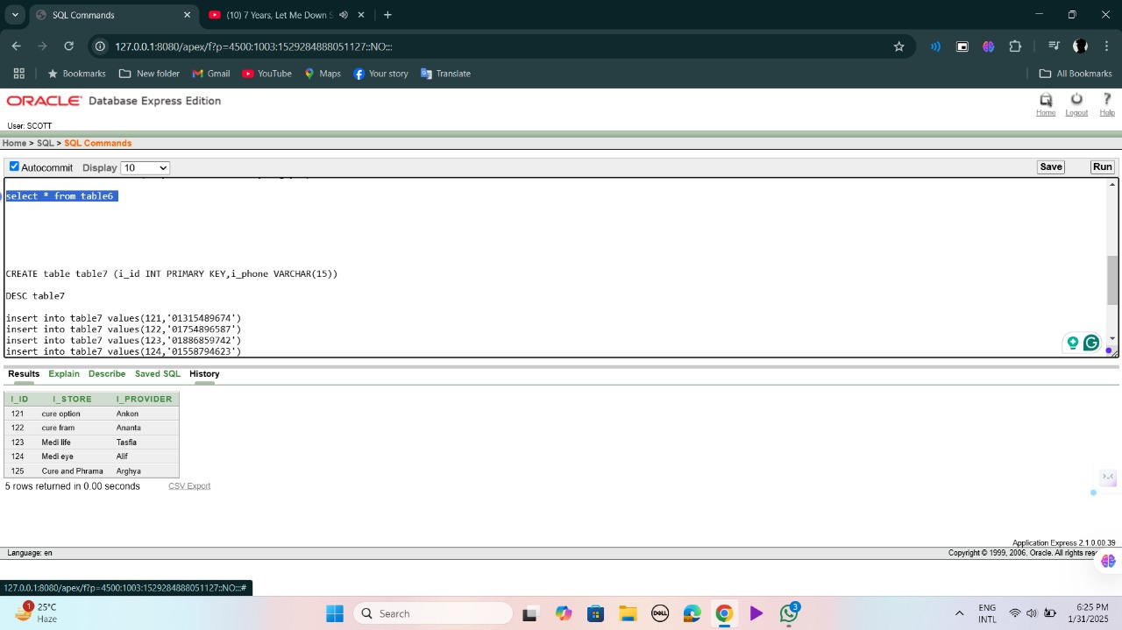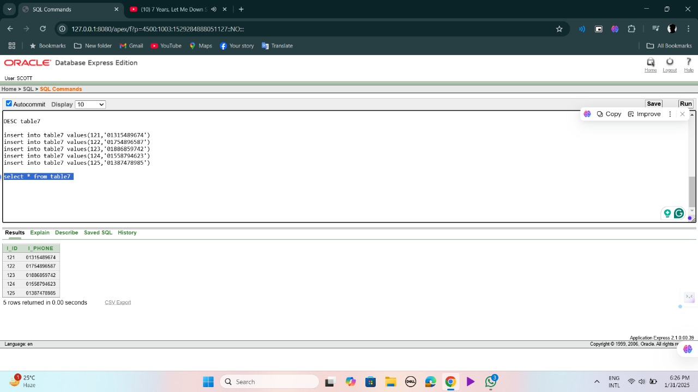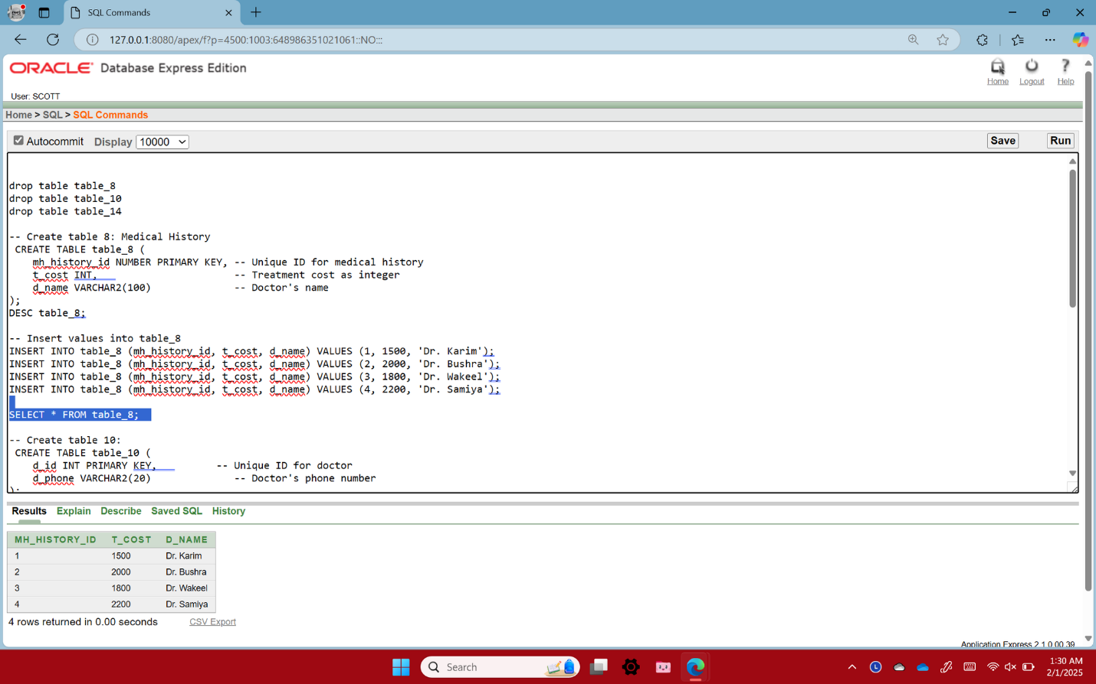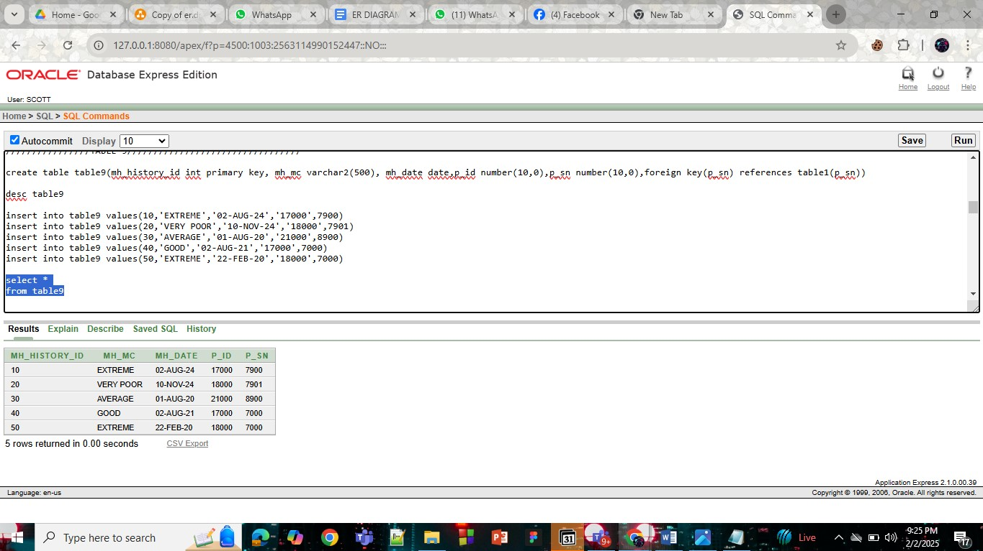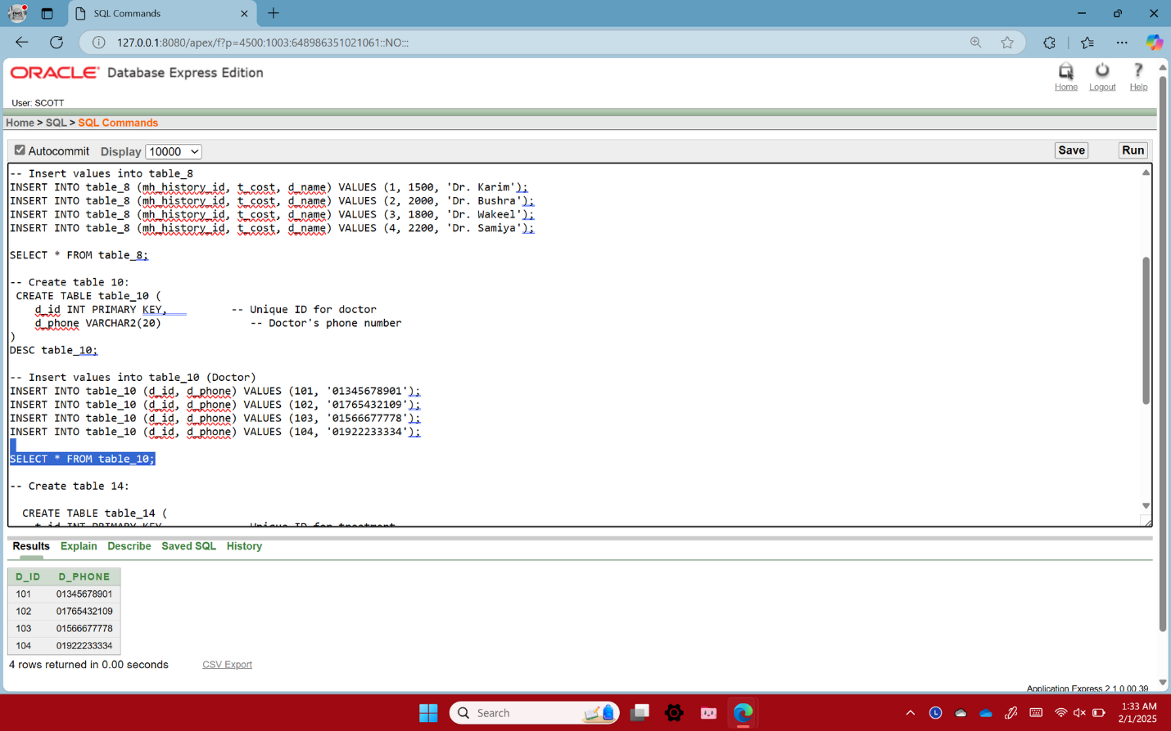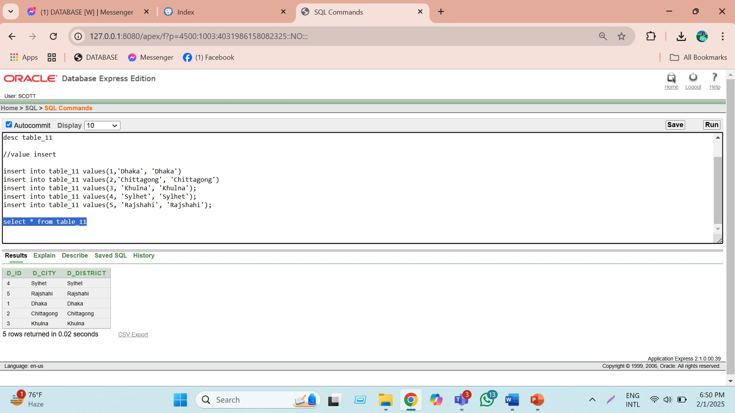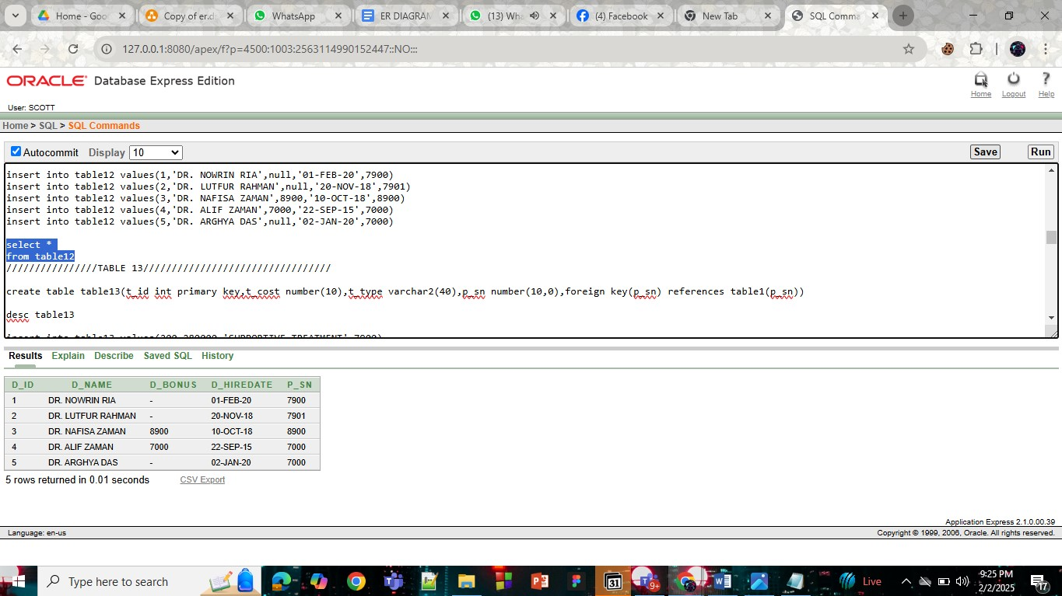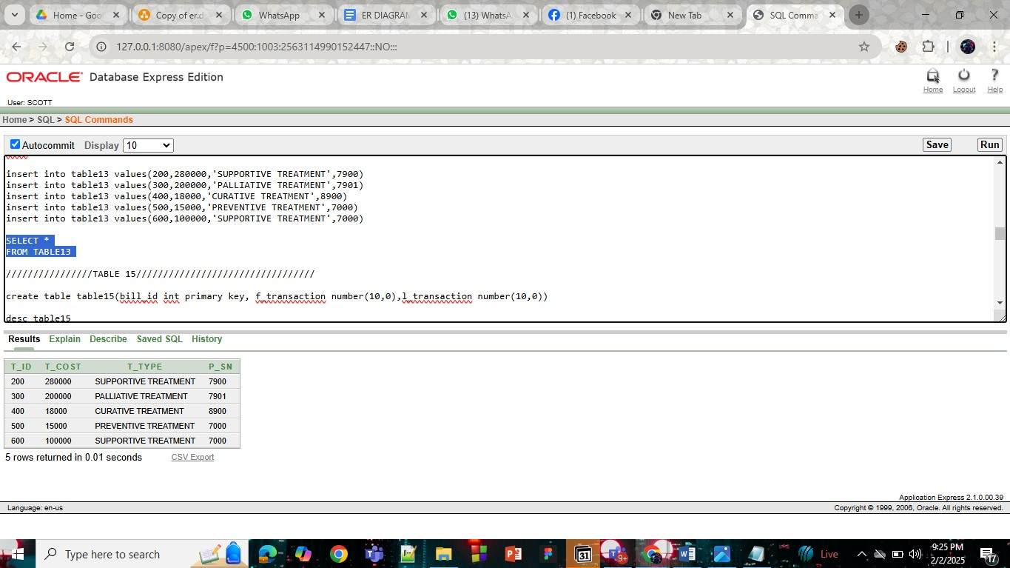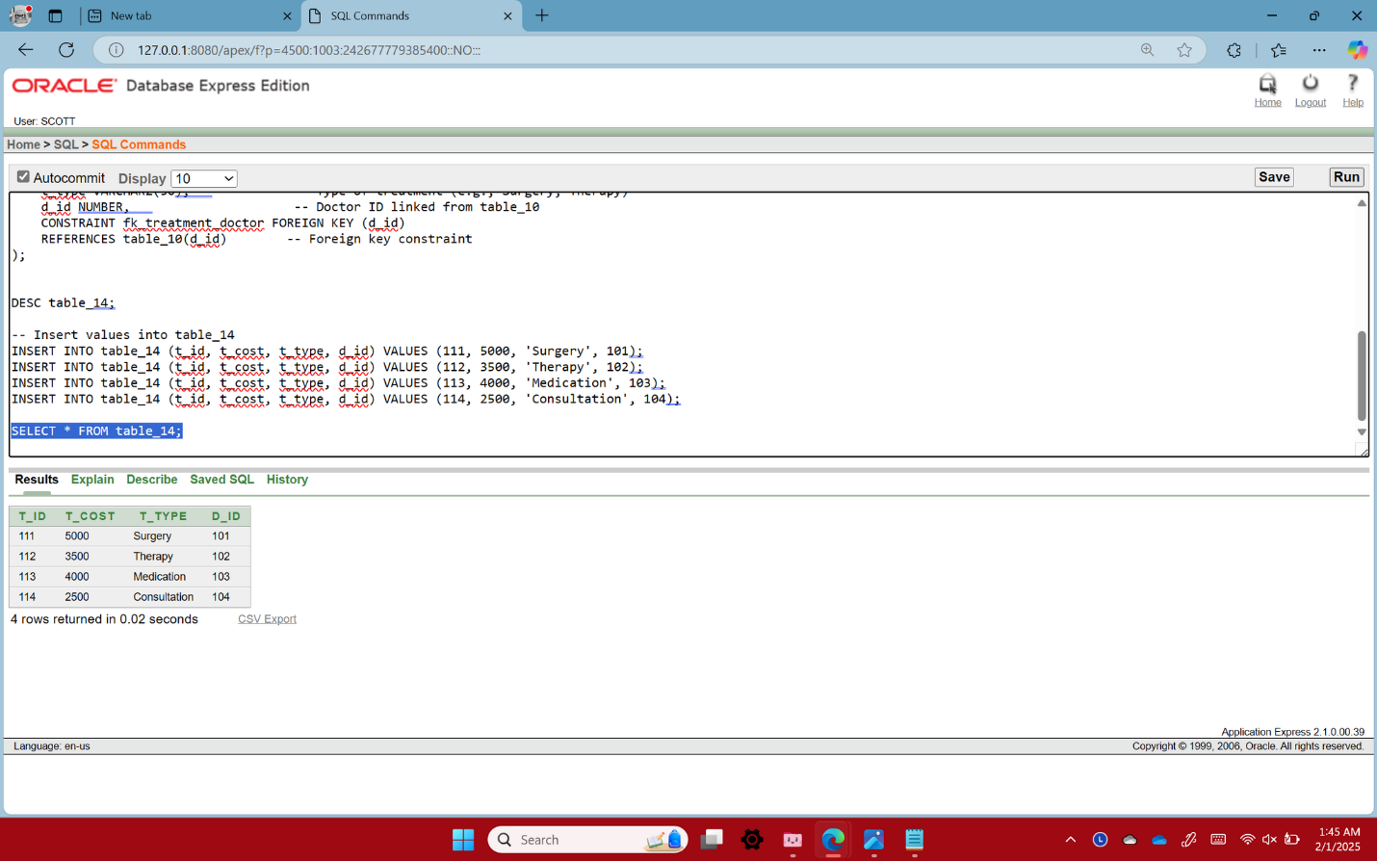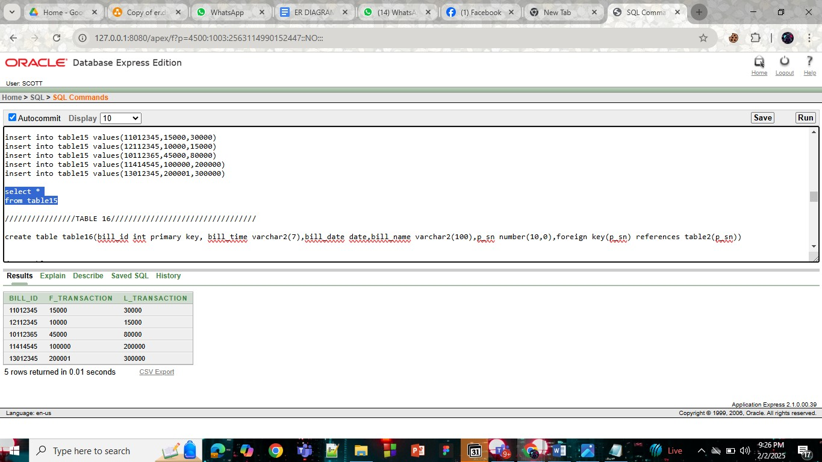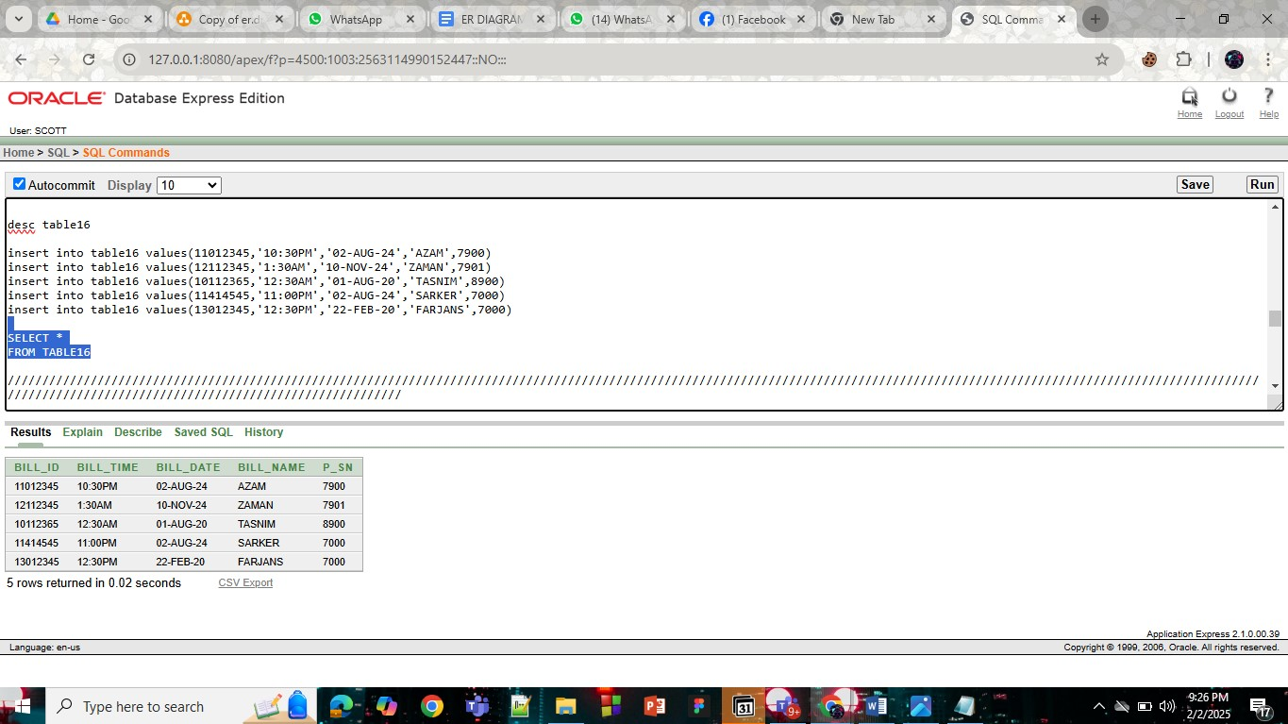

# **Query Test in DB**

## There will be one simple query. One with Group/ Aggregate function, 2 single row Subquery, 2 Multiple Row subquery, 4 different type of joining.

1. simple query
2. Query with a single row function
3. Query with a Multiple row function/ aggregate function
4. 2 Single row subquery and 2 multiple row subquery
5. 4 kinds of joining

1 simple view  
1 complex view  
  
## Provide query first, next the command for the query and at last the output:  
  
In the end show a simple view and a Complex view:  
Demo of a simple view is given below:

**1) Display the table12 information**

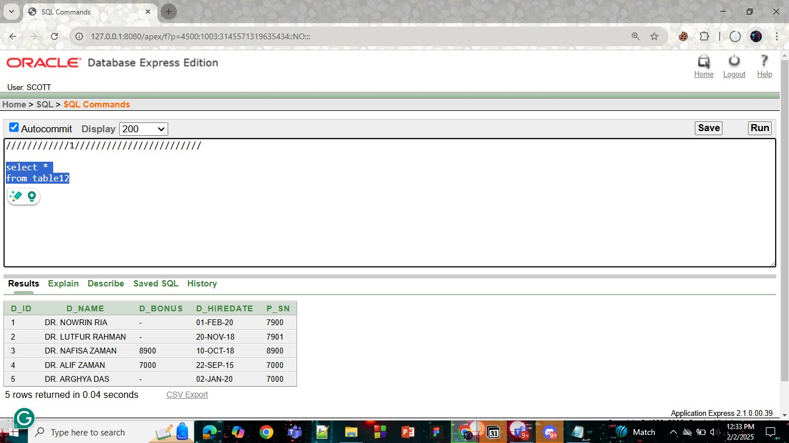

**2) Display lower case of doctor name in table4**

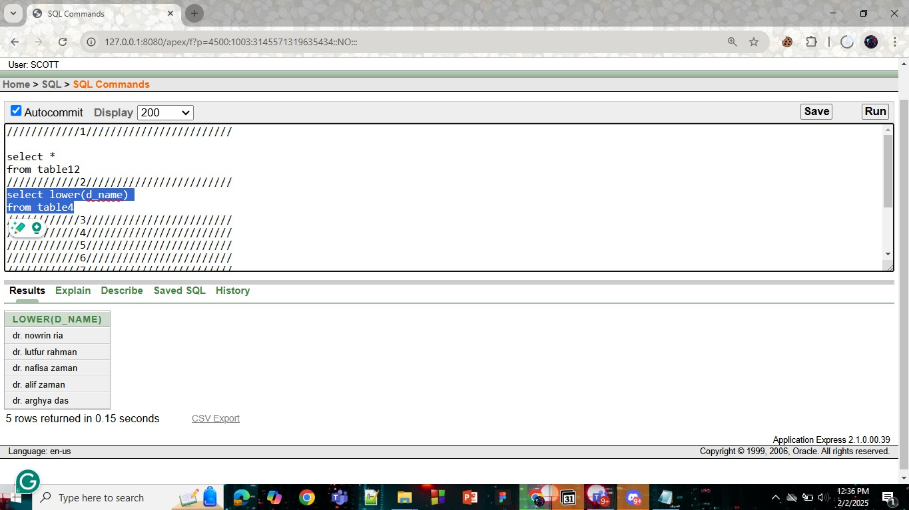

**3) Display rounded Average salary of f_transaction in table15**

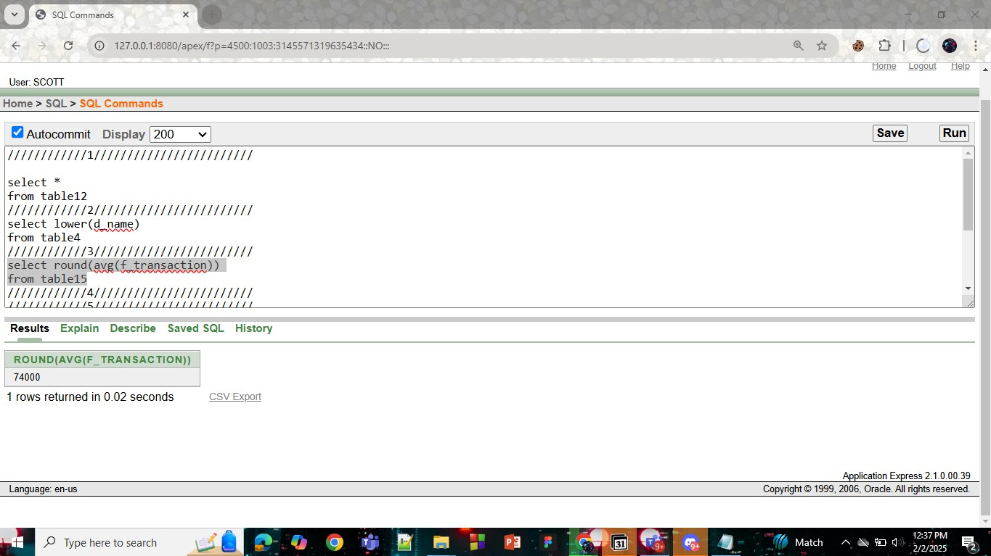

**4) Display the doctor name,appointment id,date,time of patient sanjida**

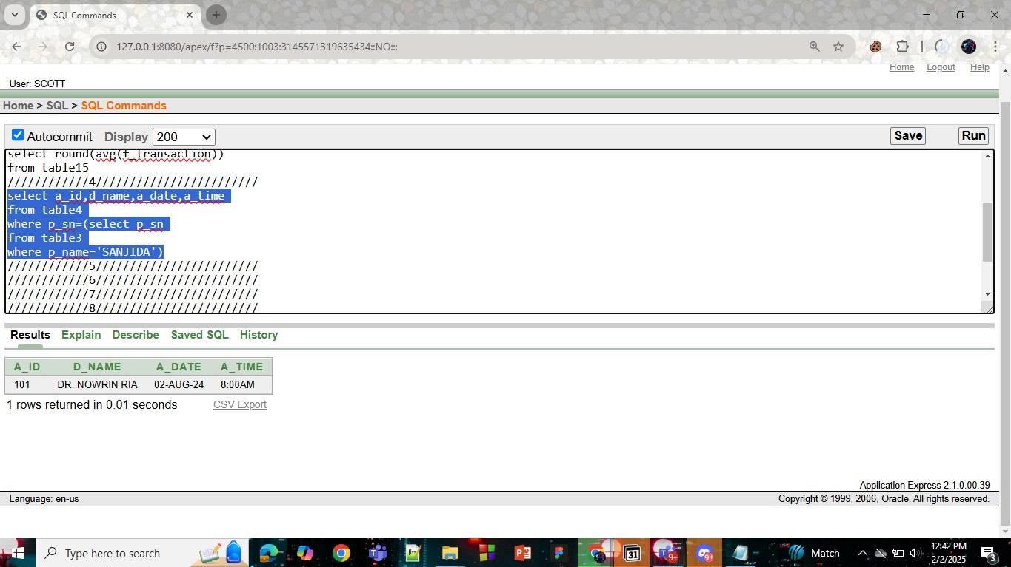

**5) Display the mh_history_id,mh_mc, of patient arghya**

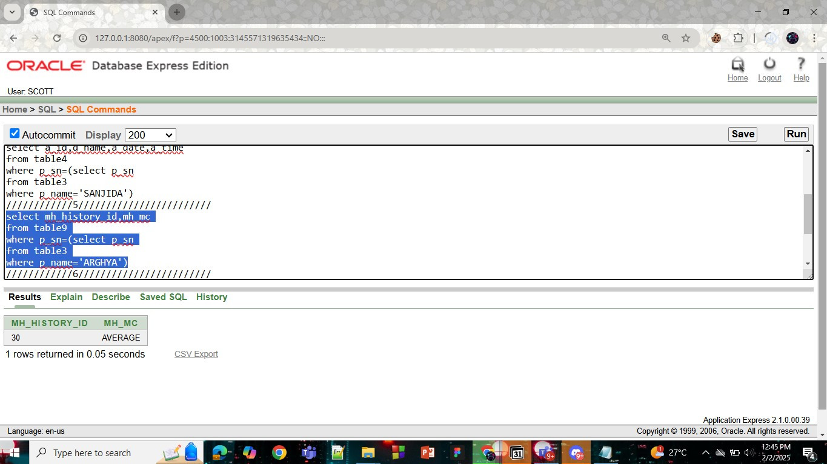

**6) Display the bill f_transaction and l_transaction which is greater than average of tretament cost**

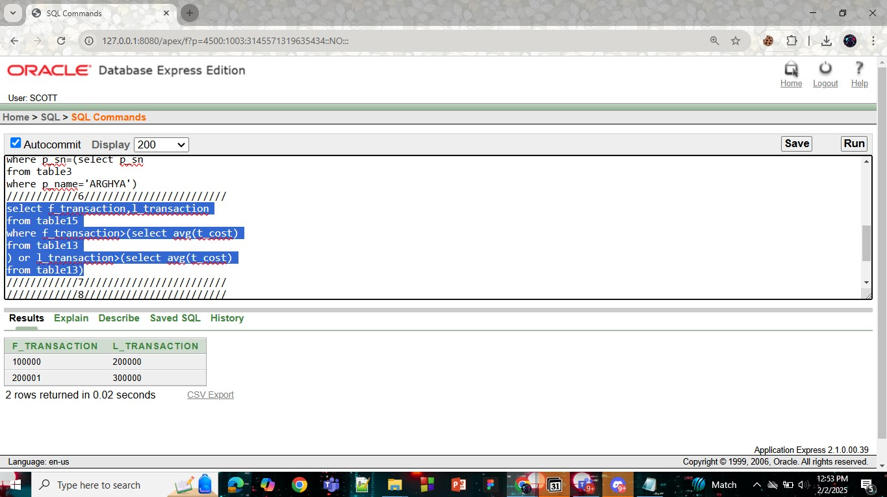

**7) Display the bill f_transaction and l_transaction which is less than sum of treatment cost**

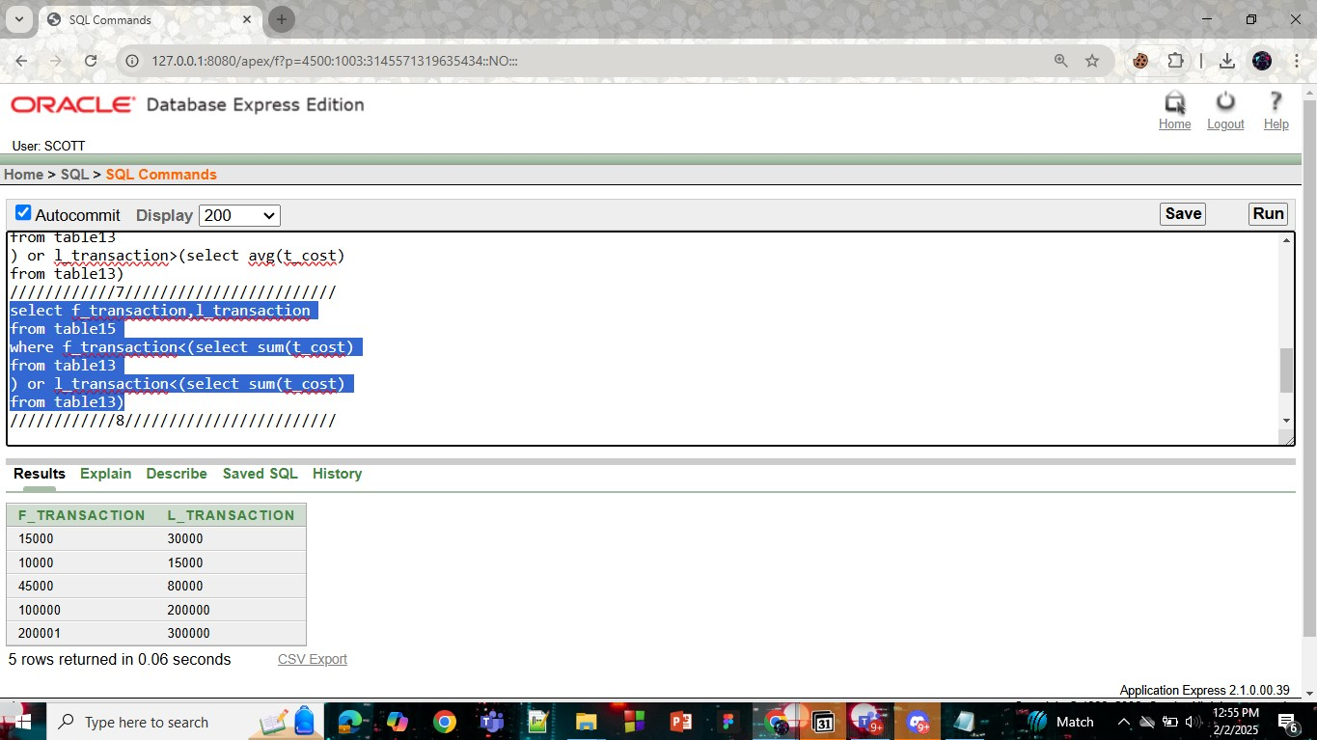

**8) Display the patient name, patient condition,appointment date,appointment time by using joining**

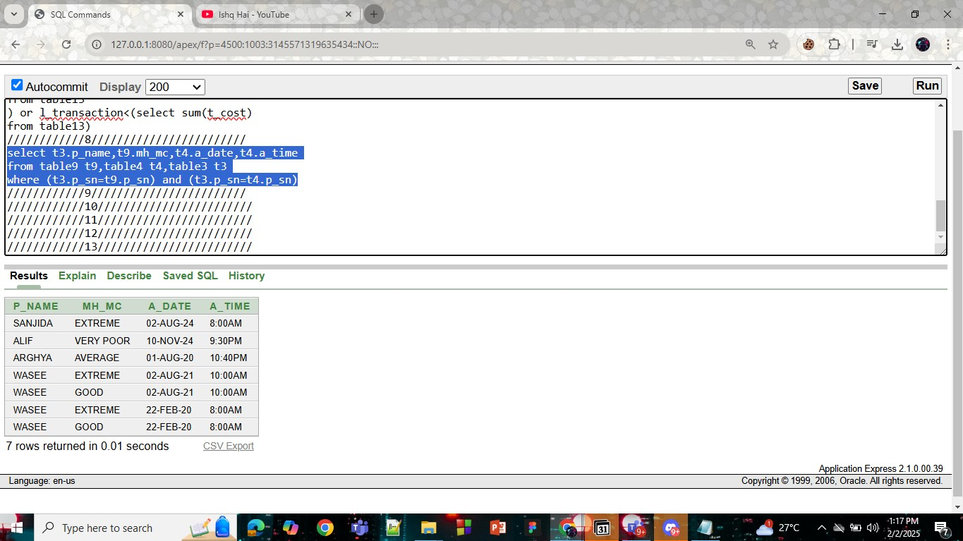

**9) Display the patient name, patient condition,appointment date,appointment time and if there is any patient serial number is not present display 'NO PATIENT' by using joining**

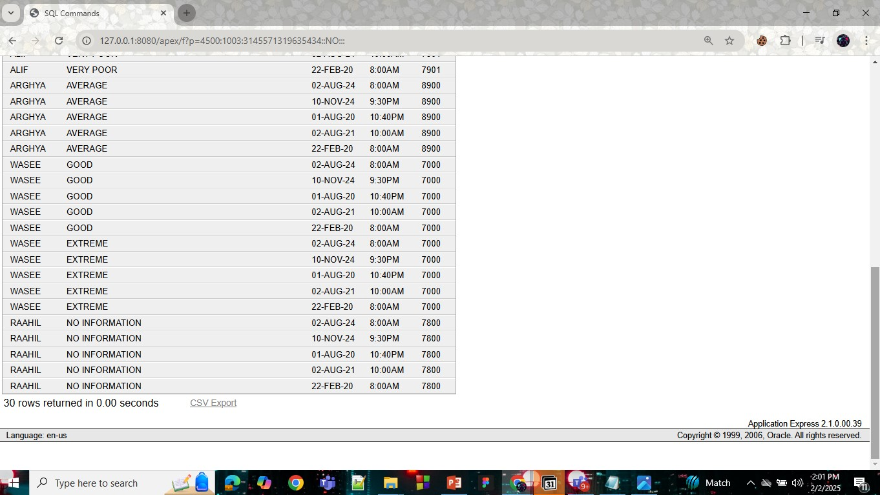

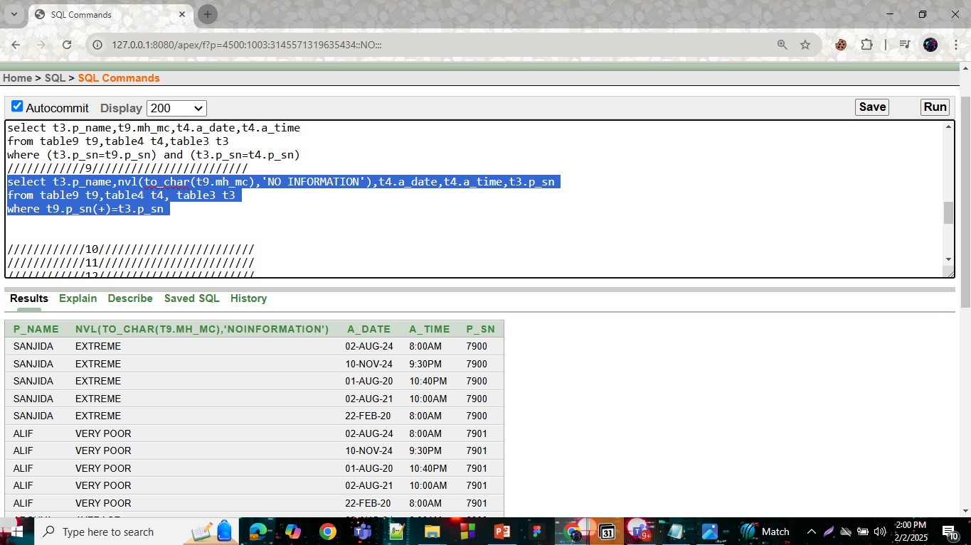

**10) Display the treatment cost between f_transaction and l_transaction by using joining**

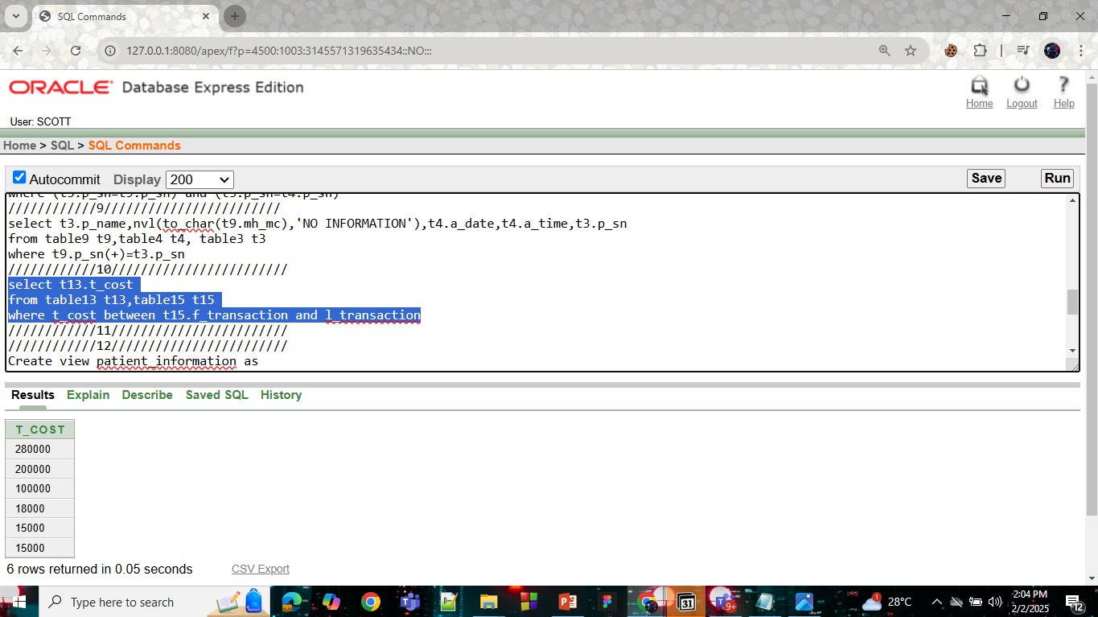

**11) Display table12 of the doctor information if d_bonus is equal to patient serial number(p_sn) by using joining**

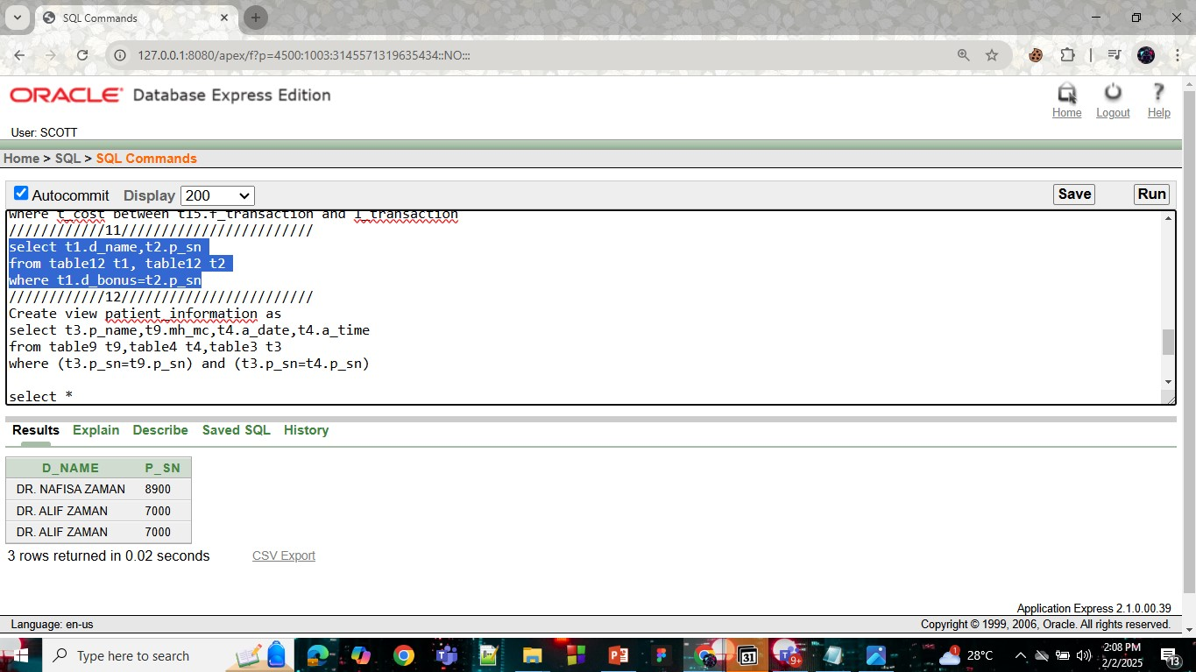

**12) Create a table patient name, patient condition,appointment date,appointment time and name as 'PATIENT_INFORMATION'**

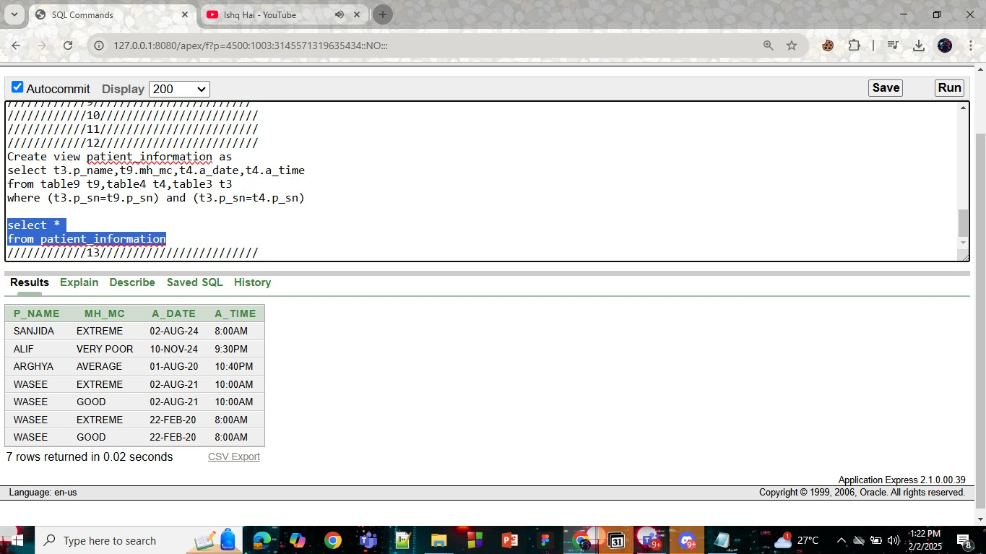

**13) Create a treatment table of avg t_cost,sum t_cost, min t_cost and max t_cost and named as 'TREATMENT_COST'**

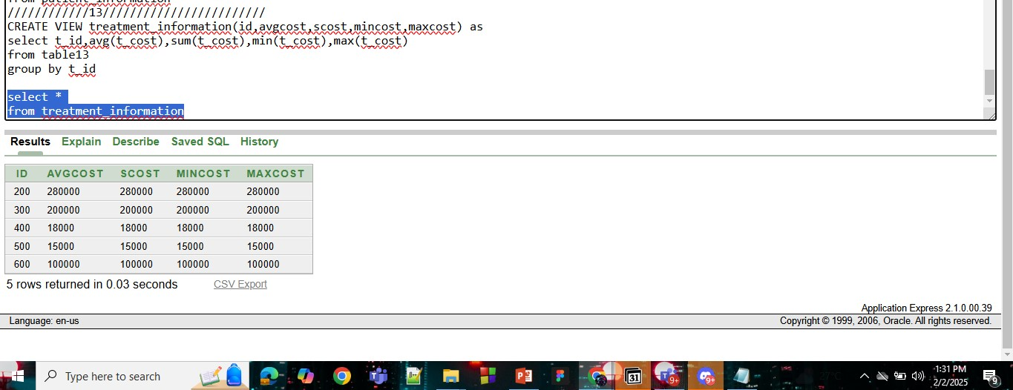

# **Description of a Successful DB connection**

## Its up to the presentation / explanation capabilities of the student. Each student has to show the DB connection process individually and put the description in this file one after another mentioning their name. Student can use either MySQL or Oracle.

what do we need?  
1. Mysql java connector (jar file)

You can go to “**mysql java connector maven” any version you like**2. You need to search (**xampp apache mariadb perl php**) install xampp server normally

3. Select the xampp icon control UI and then **start** both apache and mysql. Next go to mysql admin panel

4. now create a Database , inside of it create table and insert the values in the table

The table in mysql  
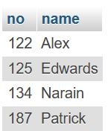

Now we need an IDE.

Before that, we need to understand the steps of DB connection

* Register Driver
* Connect the DB
* Create statement
* Execute the query () in the resultstmnt
* Connection close ()

5. Now write the DB connection code and **add the jar file location in the libraries**

The output will be  
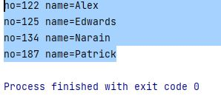

# **Conclusion**

## Mention the future aspects of the work along with a short summary of the whole project activity.